JavaScript is the programming language of HTML and the Web.

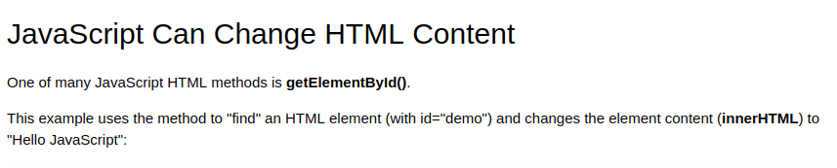

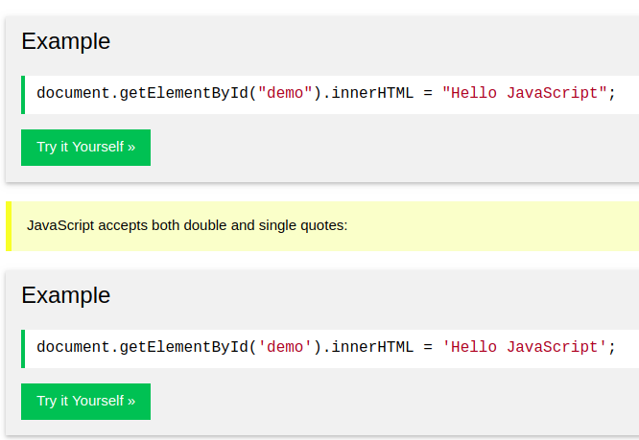

**Nice Example**

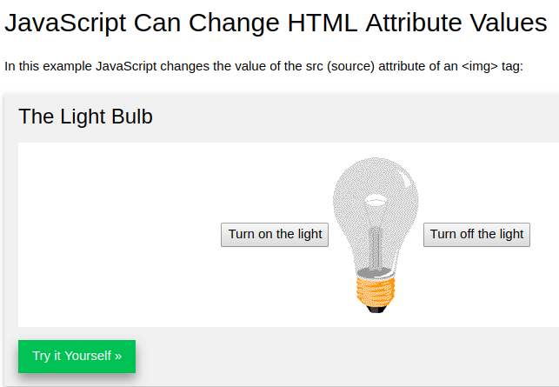

<https://www.w3schools.com/js/tryit.asp?filename=tryjs_intro_lightbulb>

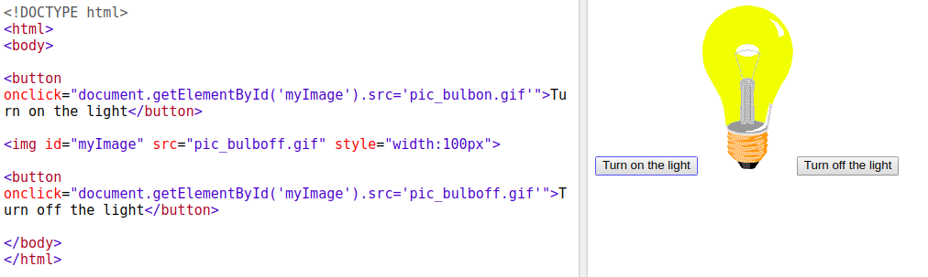

**JS css Example**

## JavaScript Can Hide HTML Elements

<https://www.w3schools.com/js/tryit.asp?filen>

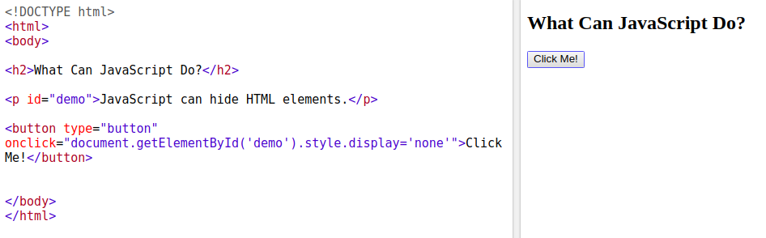

## JavaScript in <head> or <body>

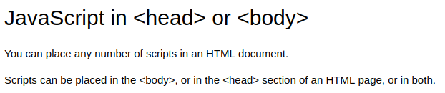



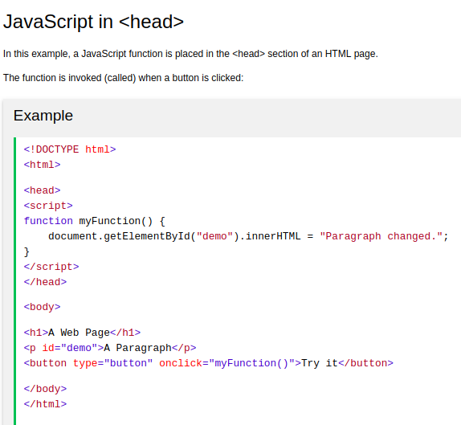

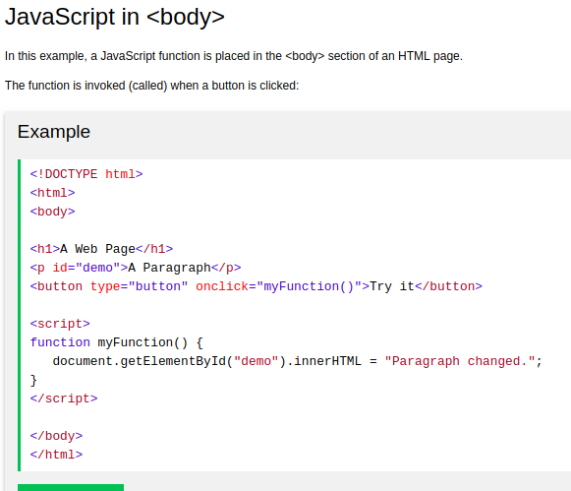

## External JavaScript

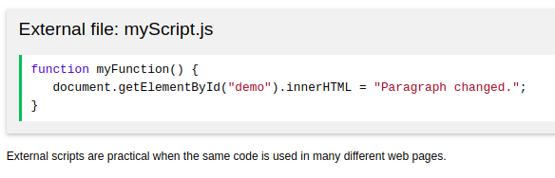

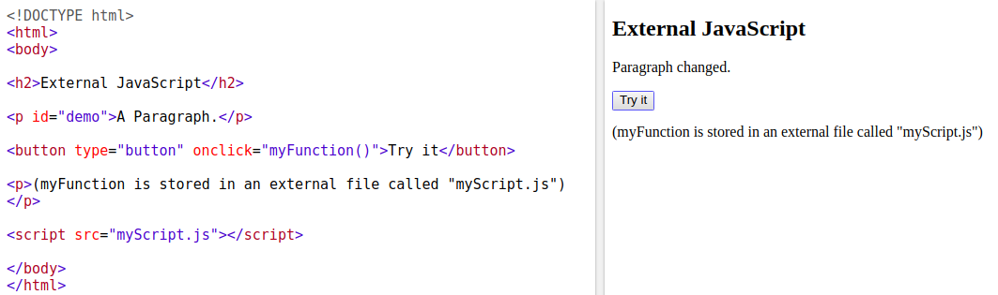

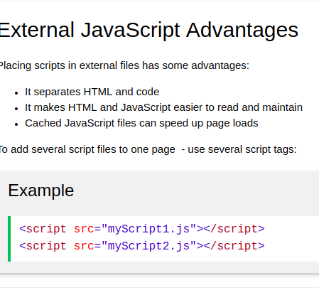

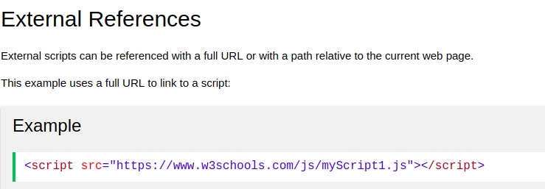

**What is Hoisting in JavaScript ? Most important question in JS developer interview**

In JavaScript, a variable can be used before it has been declared يعلن - يعرف .

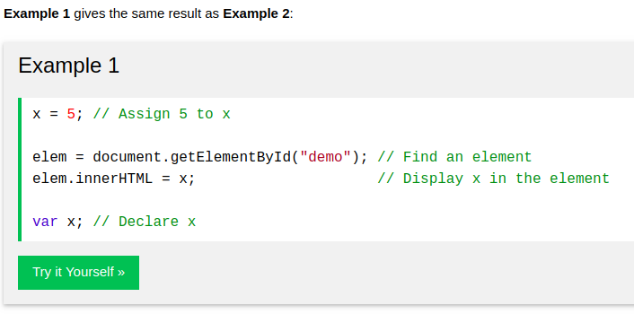



Hoisting is JavaScript's default behavior of moving all declarations to the top of the current scope (to the top of the current script or the current function).

**The math operations with Converting the ‘string’**

the + operation converts (the number when adding to string ‘’) to string.

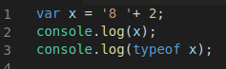

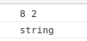

Important Note 1:

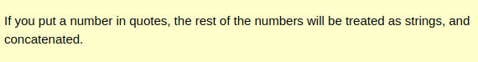

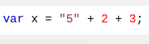

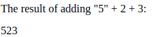

Important Note 2:

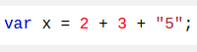

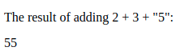

-----------------

the - * / % operations convert (the string ‘’ when adding to number) to number.

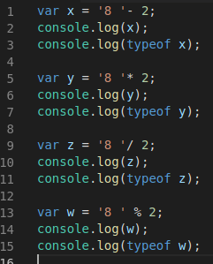

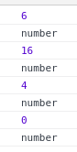

**JS HTML DOM addEventListener()**

-The addEventListener() method attaches an event handler to the specified element. تقوم بإرفاق معالج أحداث بالعنصر المحدد.

- element.addEventListener(event, function, useCapture)

- event : Required. A String that specifies the name of the event.

events: https://www.w3schools.com/jsref/dom_obj_event.asp

- function: Required. Specifies the function to run when the event occurs.

- document.getElementById("id").addEventListener("click", function(){});

- **Tip:** Use the [removeEventListener()](https://www.w3schools.com/jsref/met_element_removeeventlistener.asp) method to remove an event handler that has been attached with the addEventListener() method.

**-Tip:** Use the [document.addEventListener()](https://www.w3schools.com/jsref/met_document_addeventlistener.asp) method to attach an event handler to the document.

Ex:

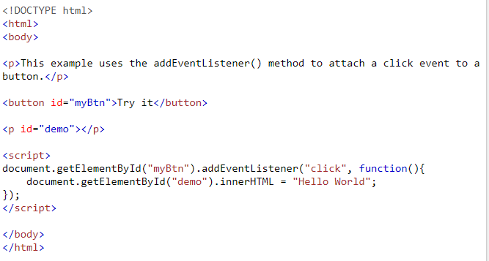

In Browser

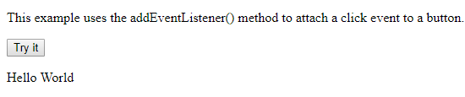

**Logical operation ! && ||**

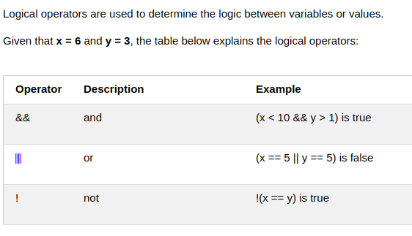

who execute first :

1  **not !**

2  **and &&**

3  **or ||**

## Conditional (Ternary ثلاثي) Operator

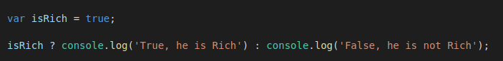

That means :

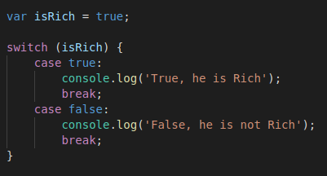

# Switch Statement

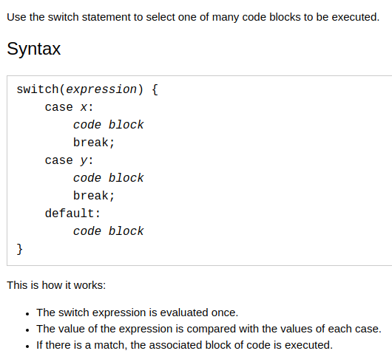

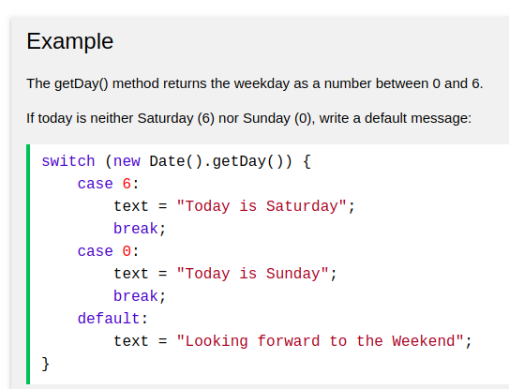

# Operator precedence - order

The following table is ordered from highe[W](https://developer.mozilla.org/en-US/docs/Web/JavaScript/Reference/Operators/Operator_Precedence)st (20) to lowest (1) precedence.

[https://developer.mozilla.org/en-US/docs/eb/JavaScript/Reference/Operators/Operator_Precedence](https://developer.mozilla.org/en-US/docs/Web/JavaScript/Reference/Operators/Operator_Precedence)

**logical for numbers and string**

0 zero as logic is false

all numbers else zero as logic is true

‘ ‘ as logic is false

‘ncjdncjdnccdkl’ as logic is true

empty array as logic is false

**To insert variables inside string**

use ` `

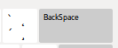

not ‘ ‘

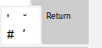

ex:



## The else if Statement ( note : and the another down if will not be executed ) that means only one if will be executed

**if** (*condition1*) {  
    block of code to be executed if condition1 is true **and the another down will not be executed**  
}

**else if** (*condition2*) {  
    block of code to be executed if the condition1 is false and condition2 is true **and the another down will not be executed**  
}

**else** {  
    block of code to be executed if the condition1 is false and condition2 is false  
}

## JavaScript Display Possibilities

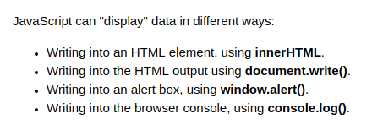

## Using innerHTML

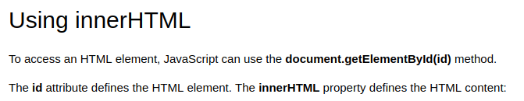

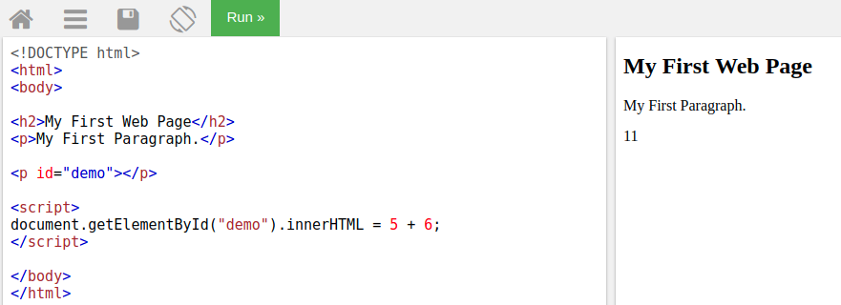

## Using document.write()



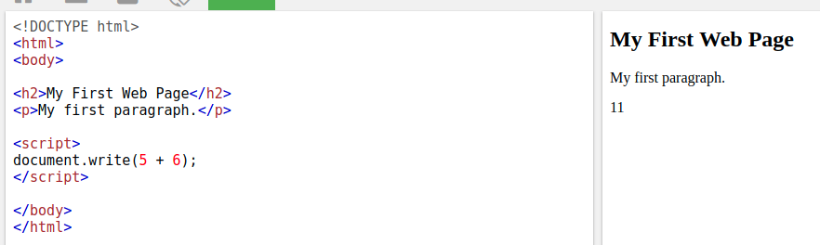



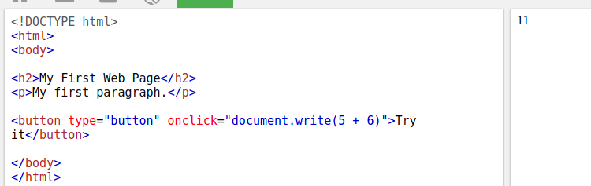

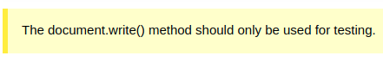

## Using window.alert()

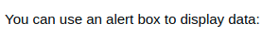

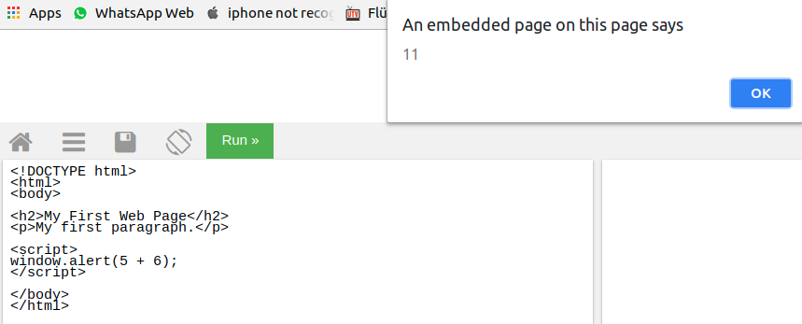

## Using console.log()

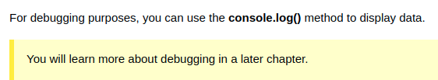

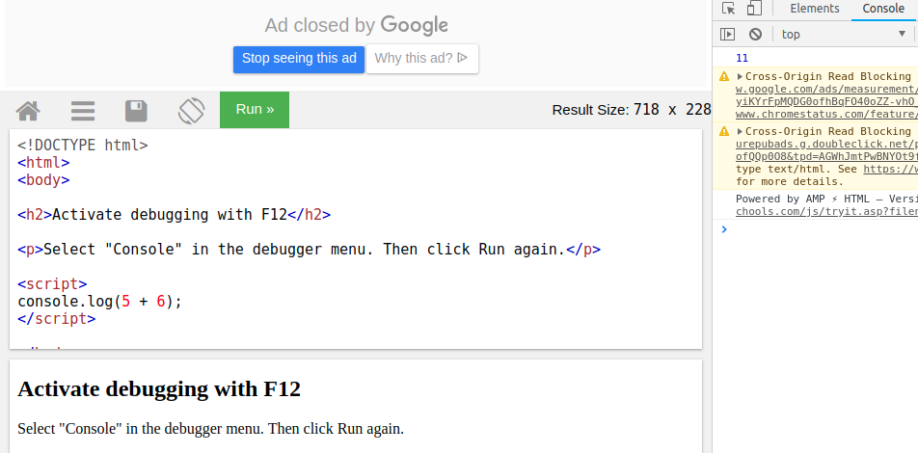

# JavaScript Statements

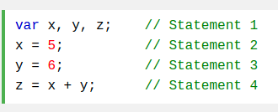

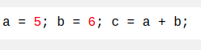

## JavaScript White Space

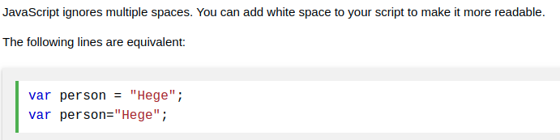

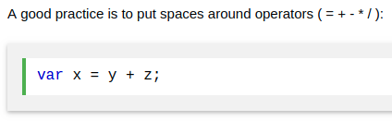

## JavaScript Line Length and Line Breaks

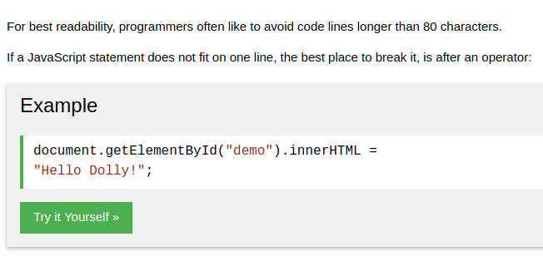

**Variable = Variable + ‘ Hallo ‘**

Variable += ‘ Hallo ‘ ;

**Classy if – one line**

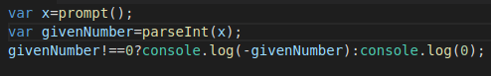

var x=prompt();

var givenNumber=parseInt(x);

givenNumber!==0?console.log(-givenNumber):console.log(0);

## JavaScript Identifiers

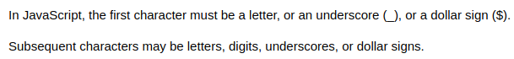

## JavaScript and Camel Case

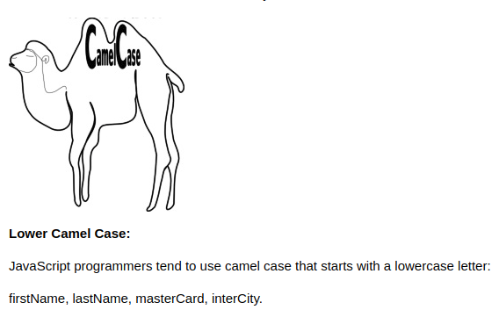

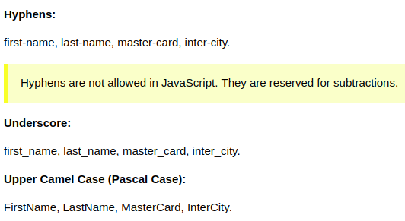

## The For Loop

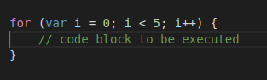

## The For/In Loop



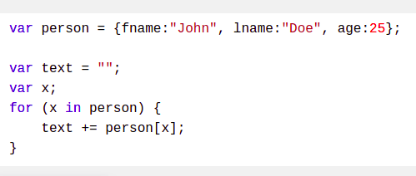

Ex:

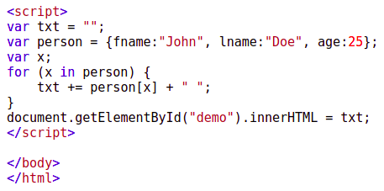

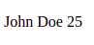

## The While Loop

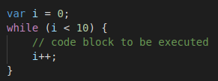

## The Do/While Loop

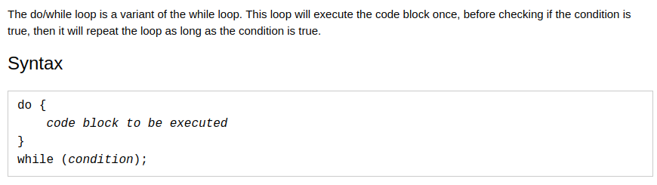

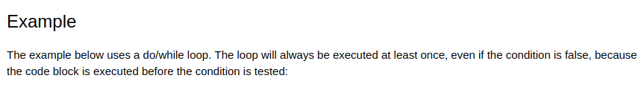

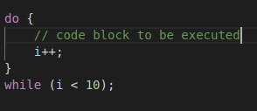

## Comparing For and While

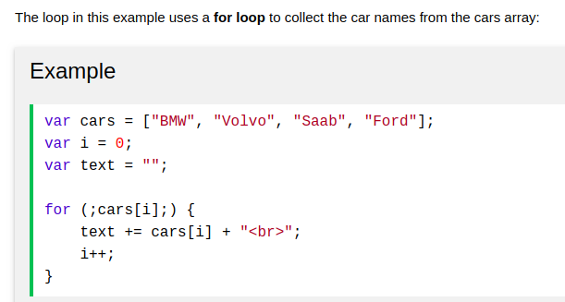

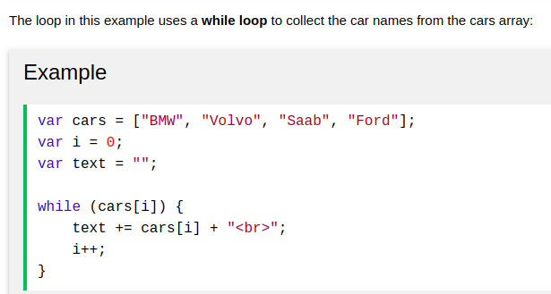

# JavaScript Functions

Ex:

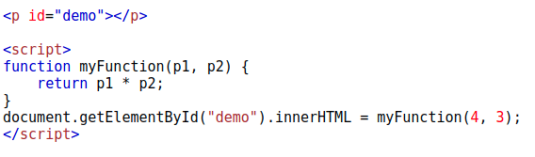

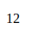**--------------------------------------------------------------------**

important

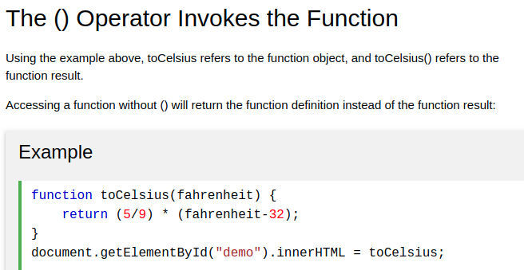

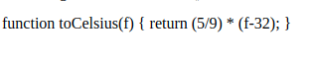

**--------------------------------------------------------------------**

important

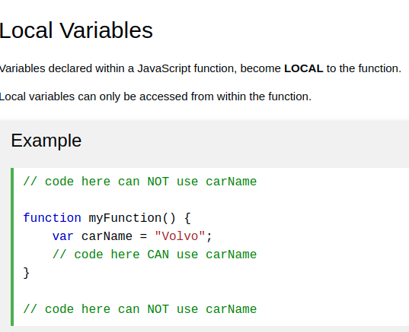

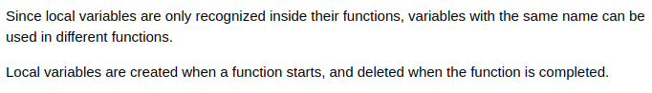

**--------------------------------------------------------------------**

Note: js function is hoisted

**--------------------------------------------------------------------**

## ( Important ) Function Return

When JavaScript reaches a return statement, the function will stop executing.

Ex: recursive function will stop will reaches a return

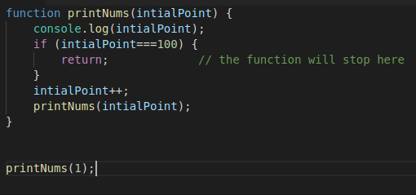

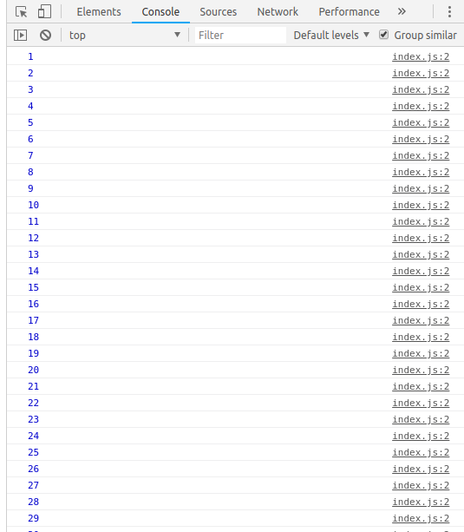

## Variables

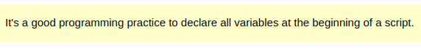-------------

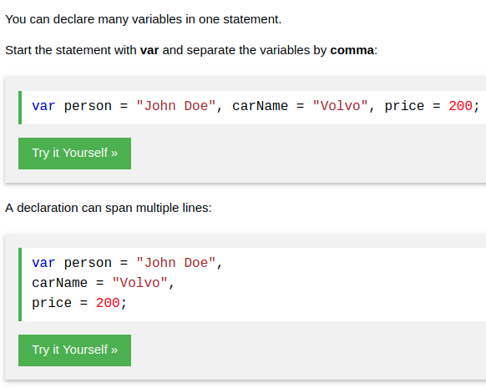

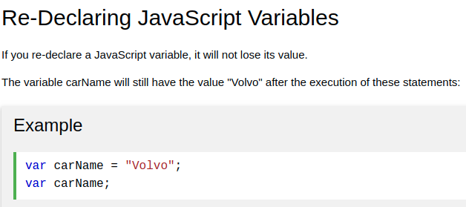

# JavaScript Let and const

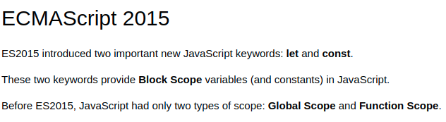

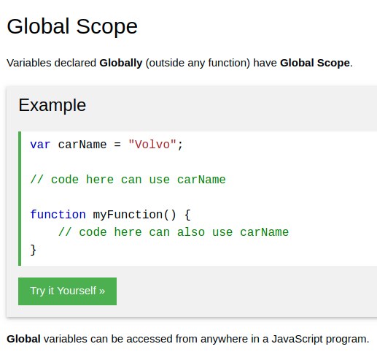

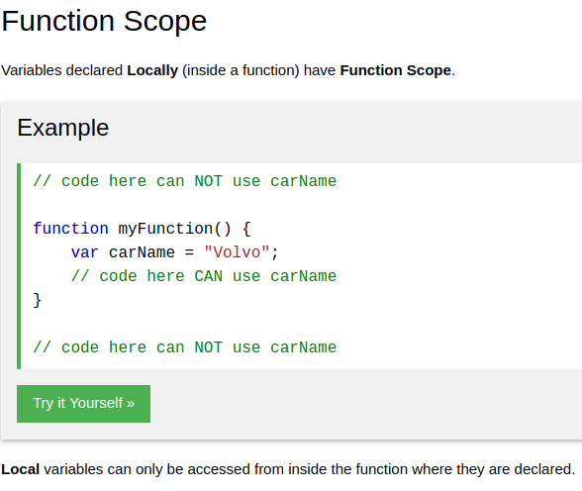

………………………….

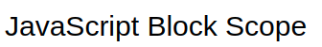

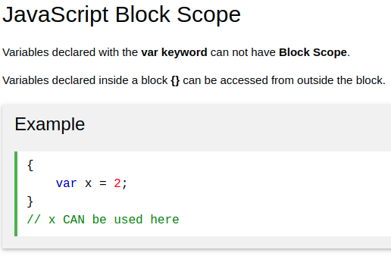

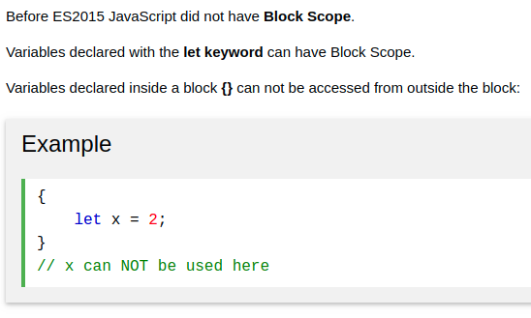

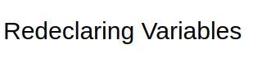

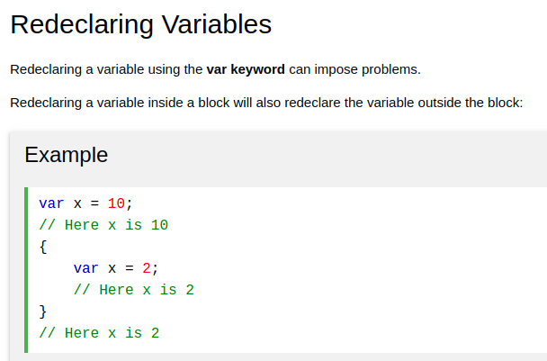

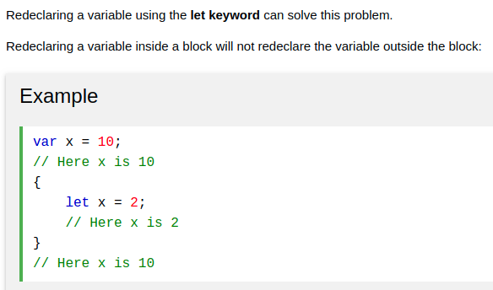

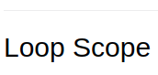

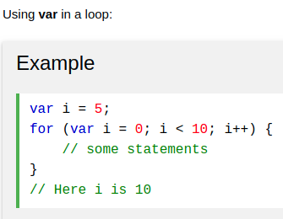

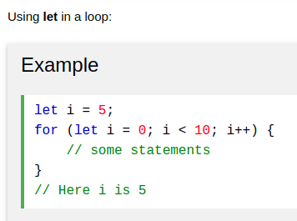

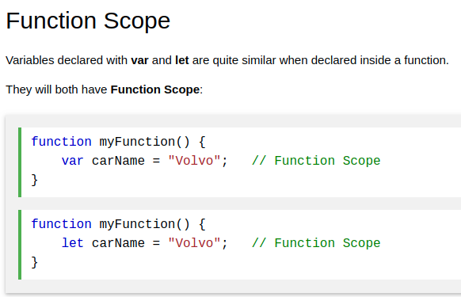

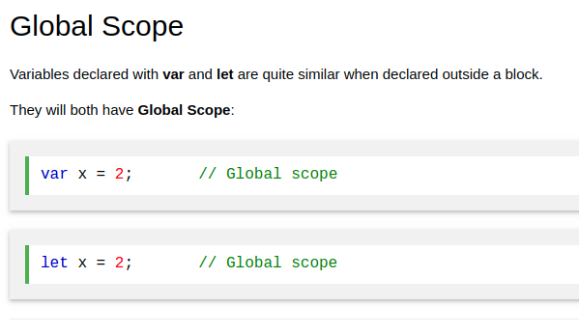

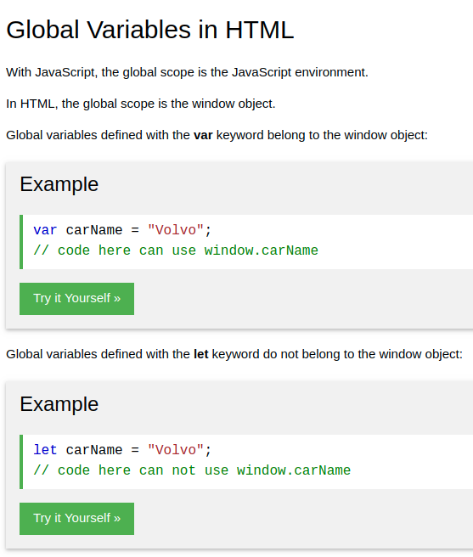

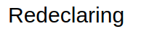

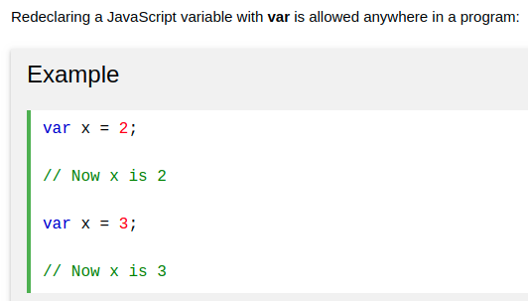

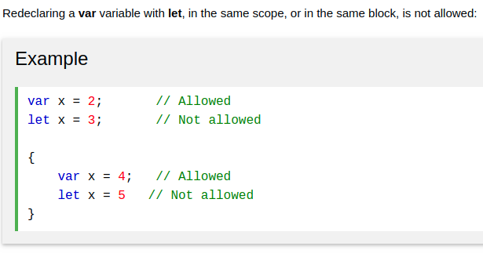

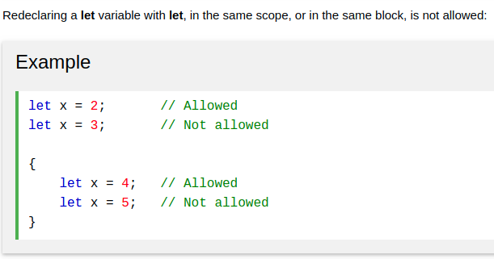

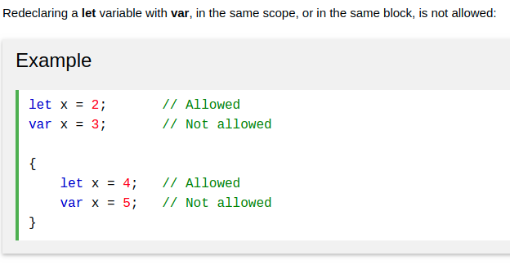

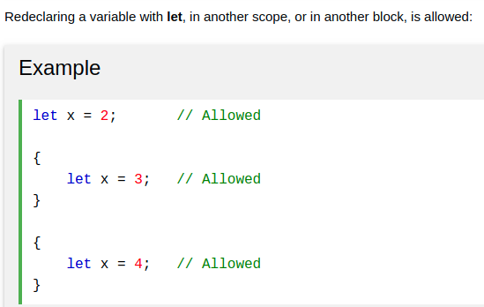

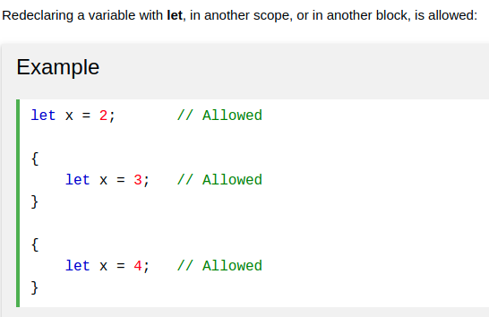

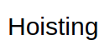

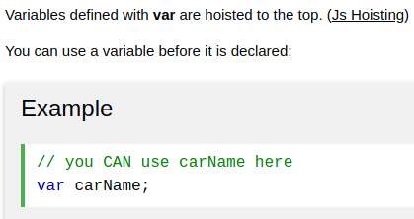

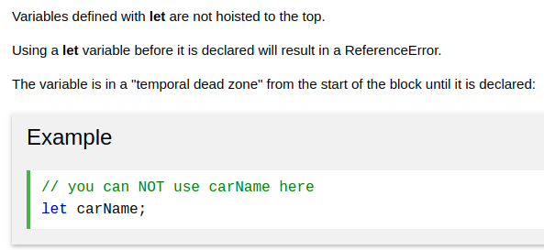

# JavaScript Const

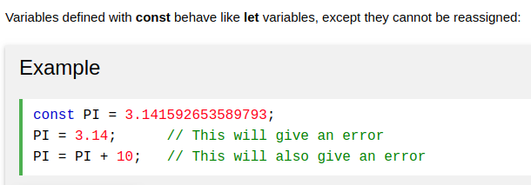

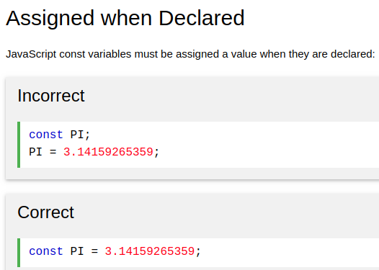

IIFE's Function

An IIFE (Immediately Invoked Function Expression تعبير دالة مستحث فورا) ,

is a JavaScript function that runs as soon as it is defined يتم تشغيلها بمجرد تحديدها.

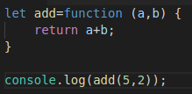

Note: The IIFE's Function is not Hoisting

**Functional programming (interview question)**

**= function Argument as function(x, y, function)**

the function accepts an argument(variable) as function.

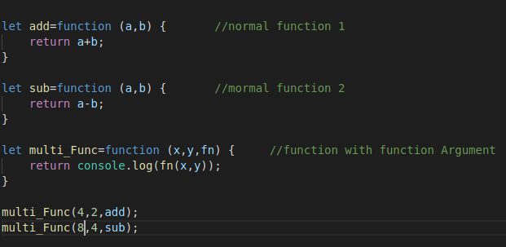

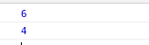

**Objected-oriented programming**

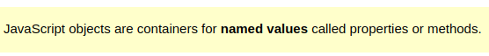



Ex1:



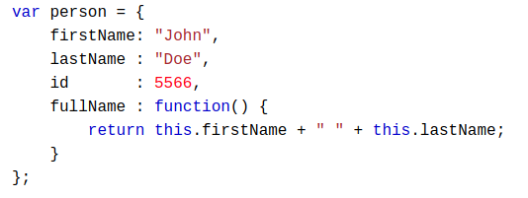

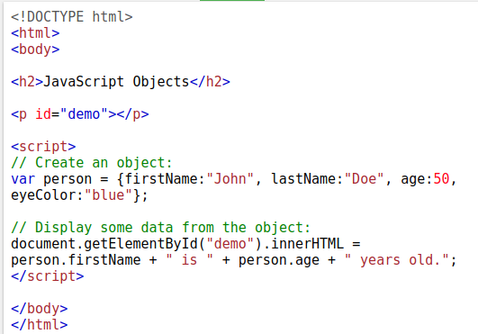

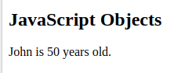

Ex2:

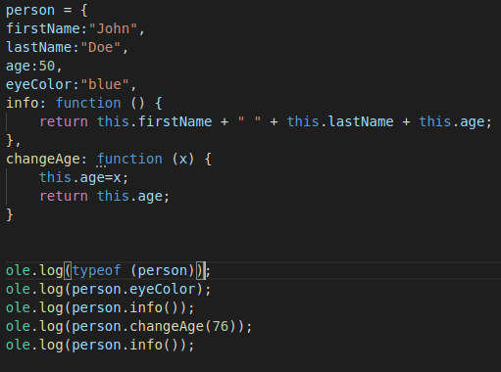

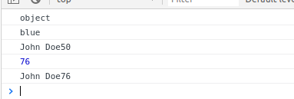

**Note: it can to create new properties later without declaring in the object.**

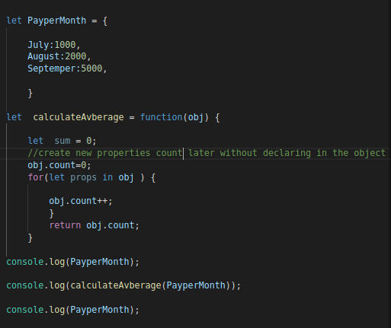

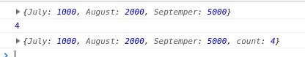

**Object Inheritance**

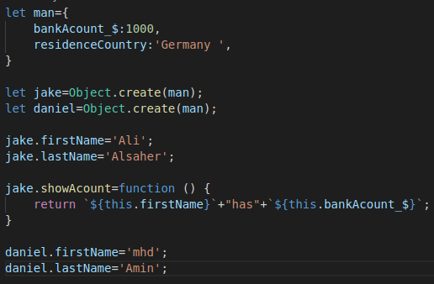

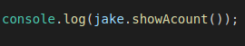

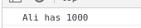

or

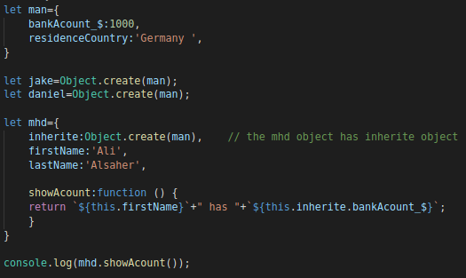

**this**

In a function definition, this refers to the "caller" of the function.

1 - This.numOfsales +=; ===> this=owner the function

2- if an object( ALI ) calls the above via inherits ===> this=ALI

that means This.numOfsales=ALI. NumOfsales

so the compiler will replace “this” with “ALI”.

Ex:

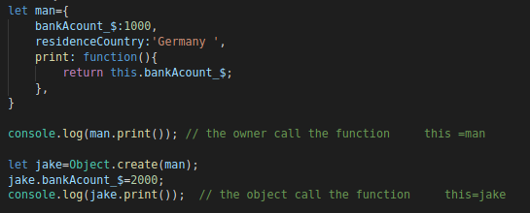

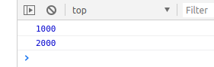

**JavaScript Arrays**



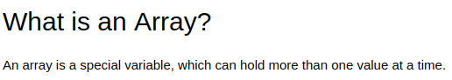

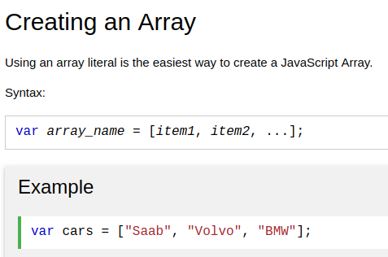

the data type of array is : object

ex:

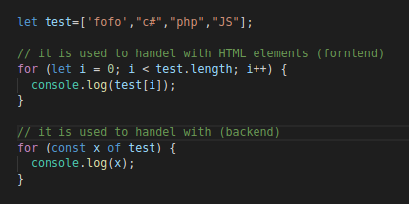

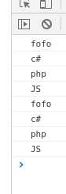

the first item is ; [0]

the last item is ; [length - 1]



**Array.includes() to compare**

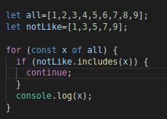

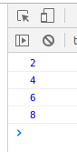

Array's methods

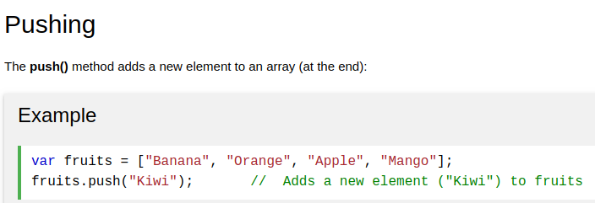-------------------------------------------

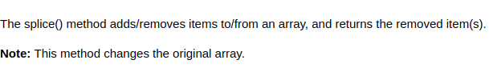

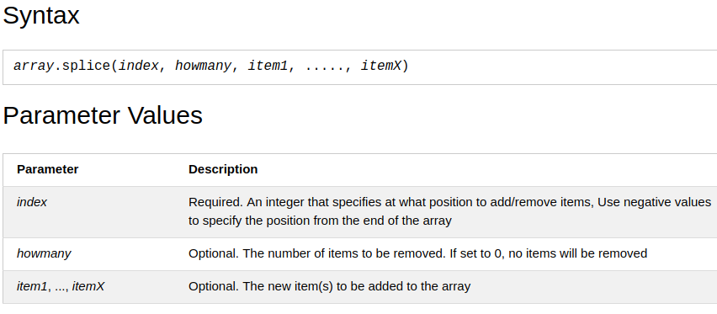

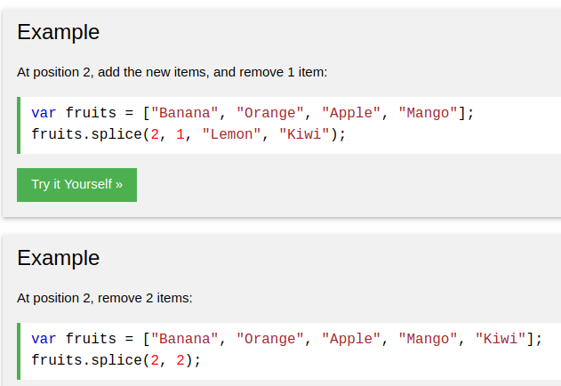

**-------------------------------------------------------**

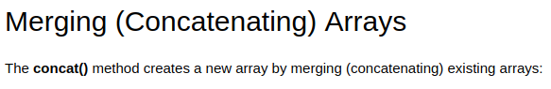

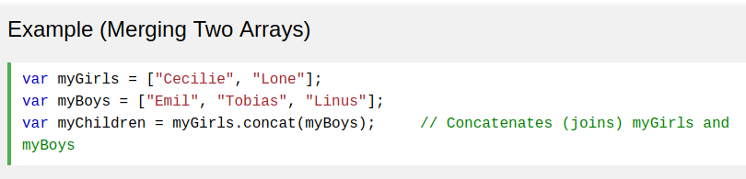

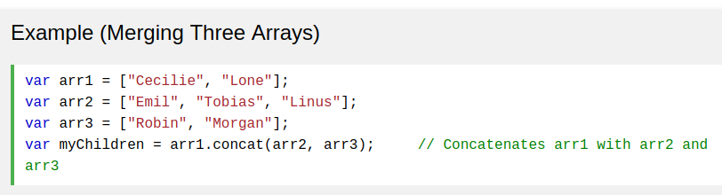

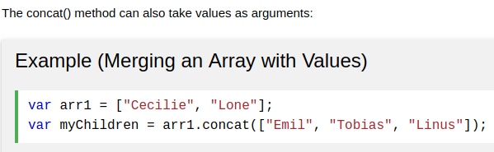

**to reverse array array.reverse()**

**to sort array array.sort()**

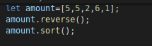

or

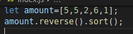

## Converting an Array to String

**array.join()**

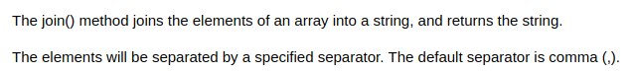

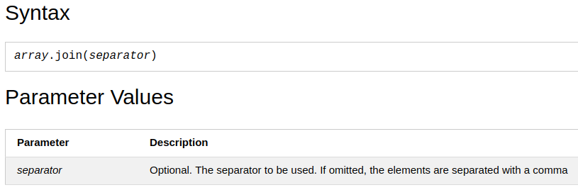

**ex:**

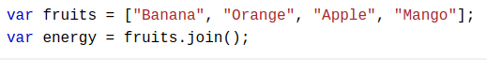



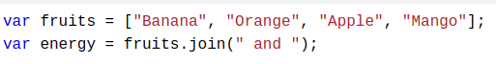

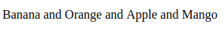

## Converting a String to an Array

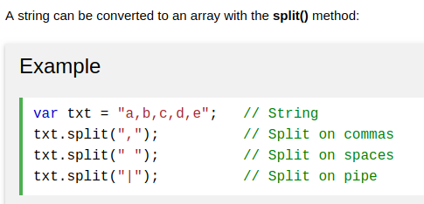

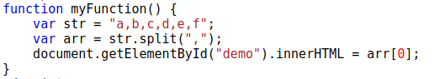

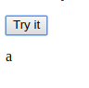

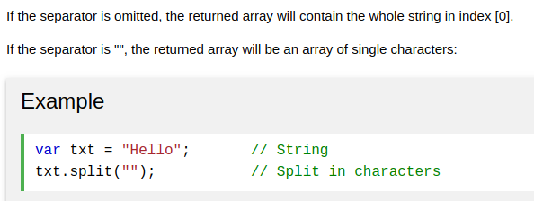

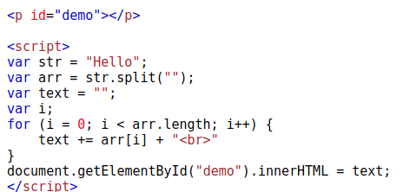

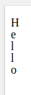-----------------------------------------------------------------------------------------------

# String Variable is like array

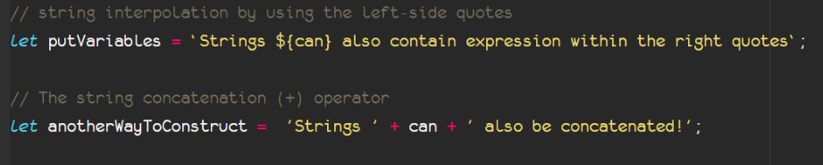

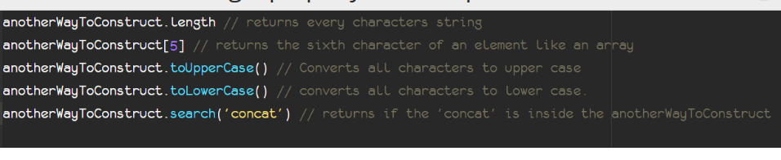

# Nested Arrays

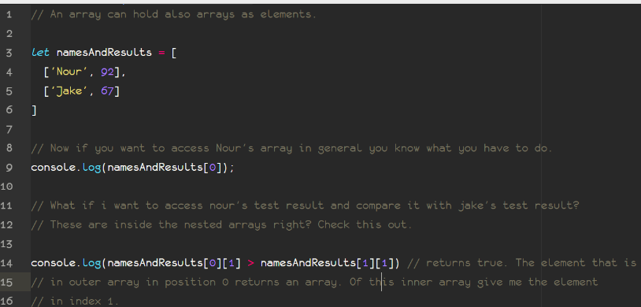

Ex:

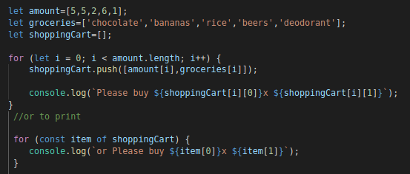

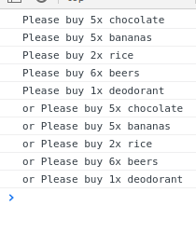

inheritance ( Constructor+Prototype )

**1-New Constructor منشئ جديد**

Another way to create objects is by creating a constructor pattern and then fill the properties with the values as shown

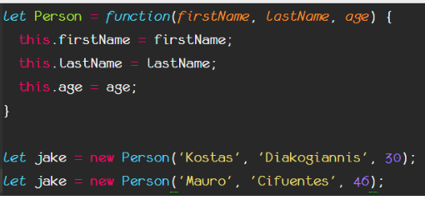

**2-New Constructor+** Prototype inheritance

A better way to set an object to inherit the properties of another object is by the Object.setPrototypeOf.

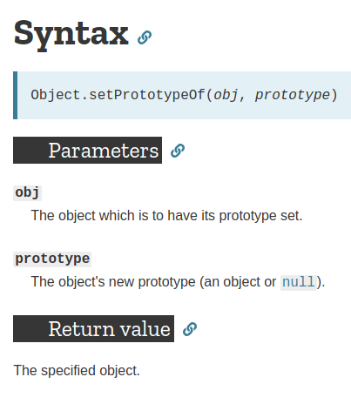

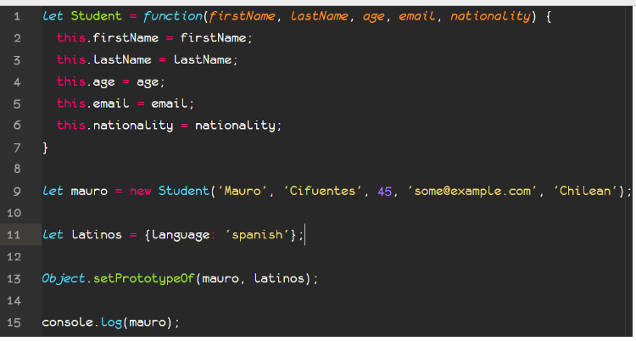

# Date Objects

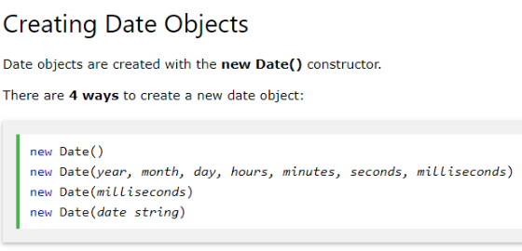

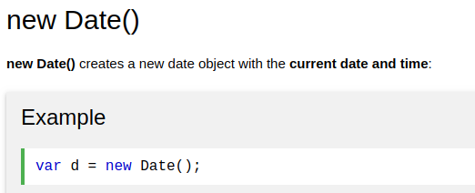

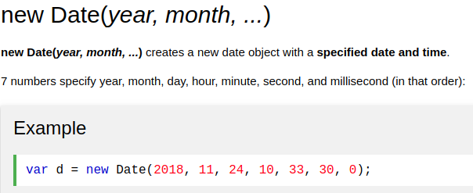

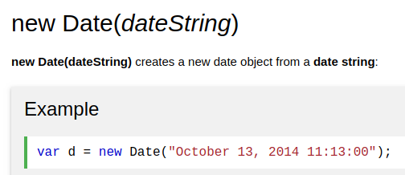

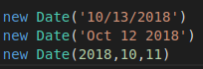

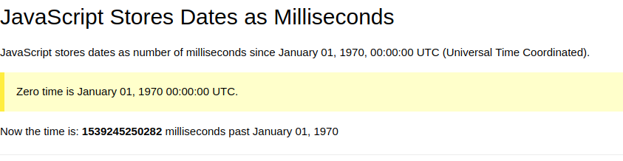

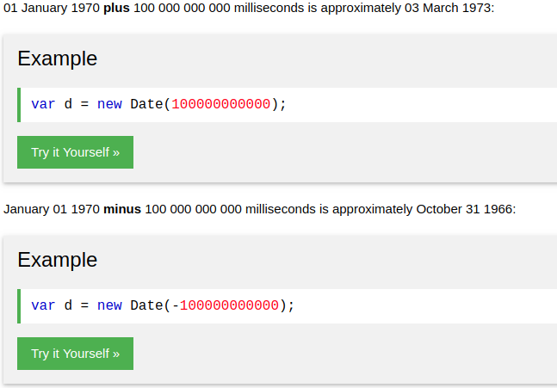

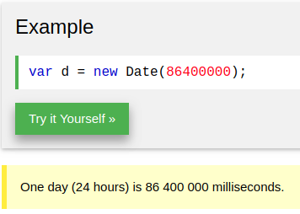

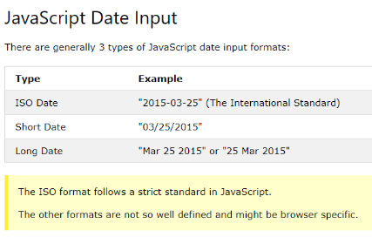

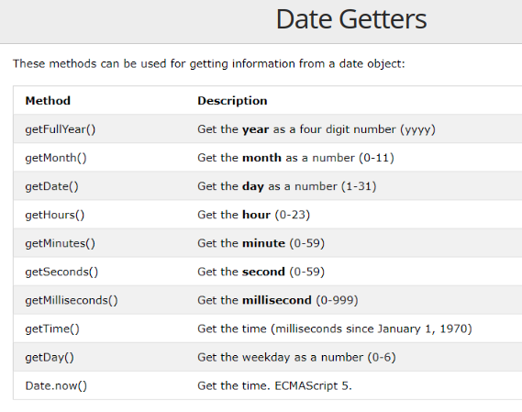

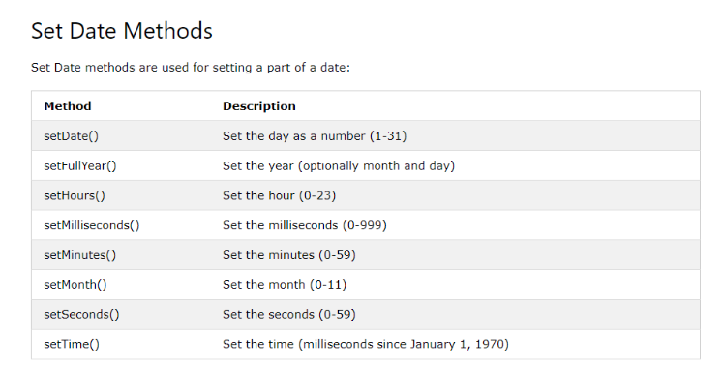

**Return**

Return will break everything ( function, while, for, if, ………) in any code.

That mean the last line will execute, is “Return”.

# JavaScript Array find() Method

**Or high order function for array**

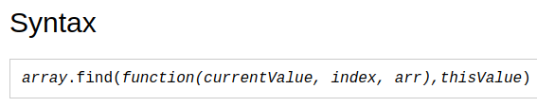

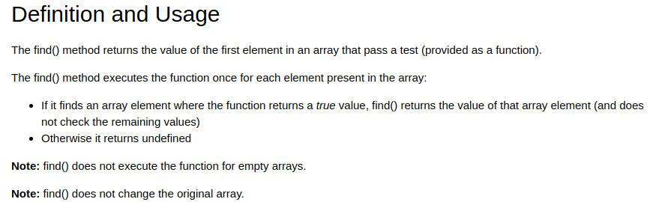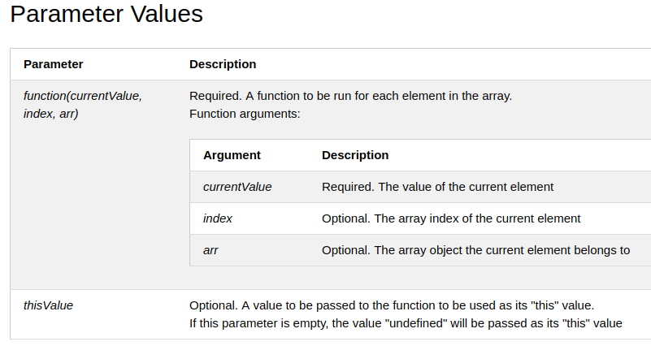

Ex:

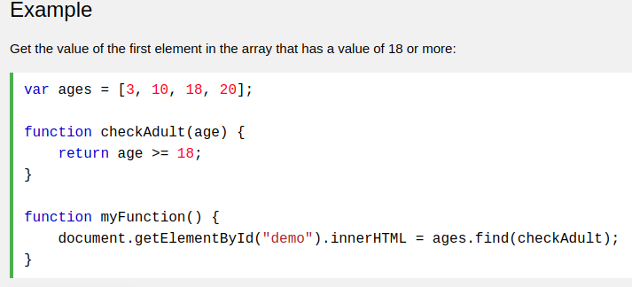

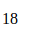

## JavaScript Assignment Operators

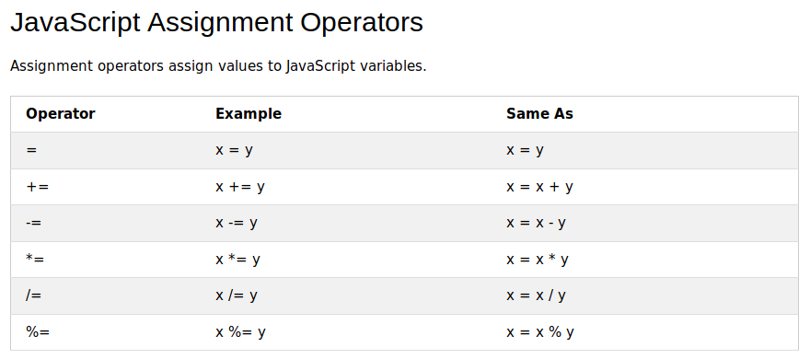

# Timing Events

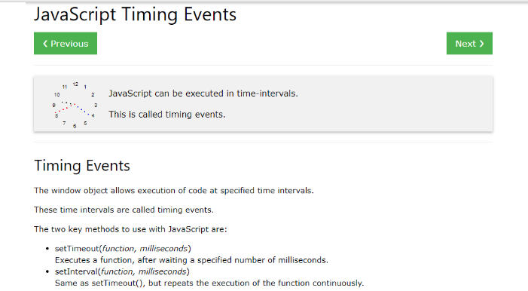

Attention: Both timing events (setInterval and setTimeout) run asynchronously.

Setting an interval function

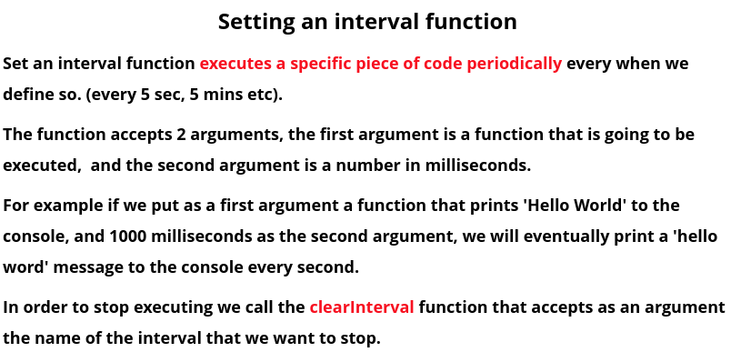

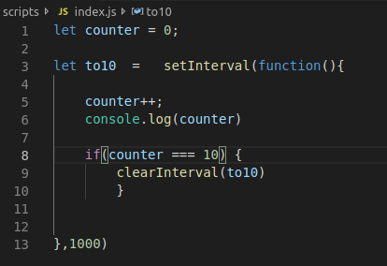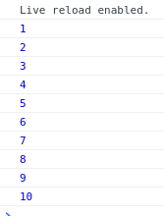

Setting a timeout function

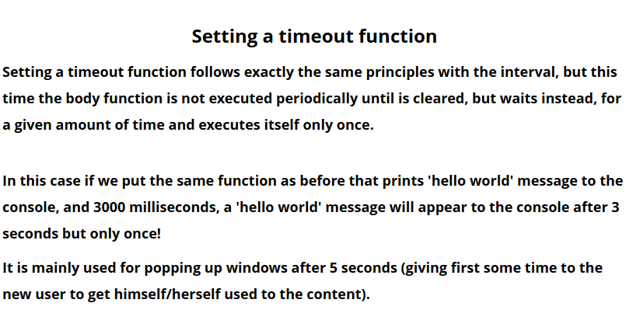

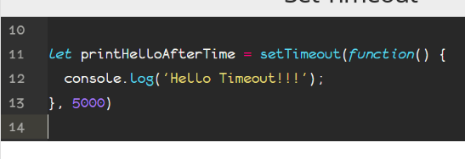  
Selecting DOM elements

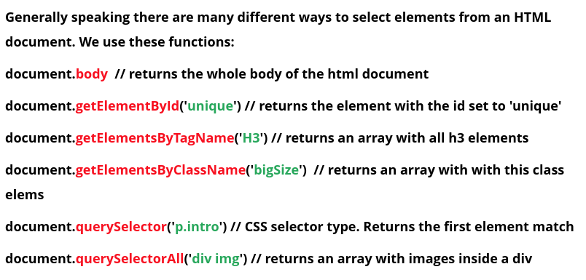

# **HTML DOM querySelector() Method**

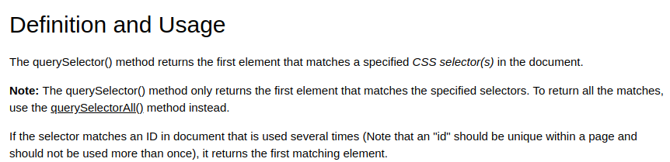

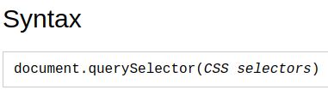

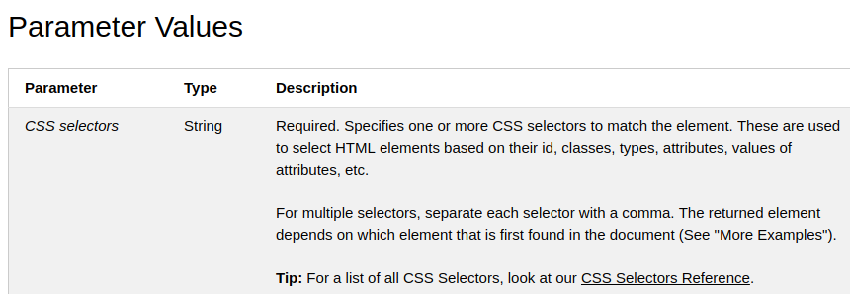

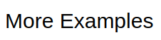

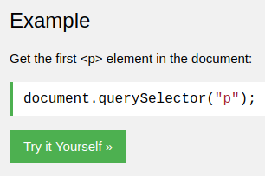

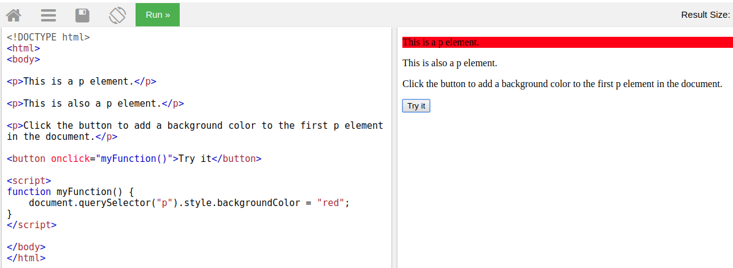

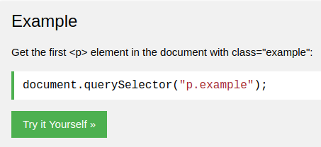

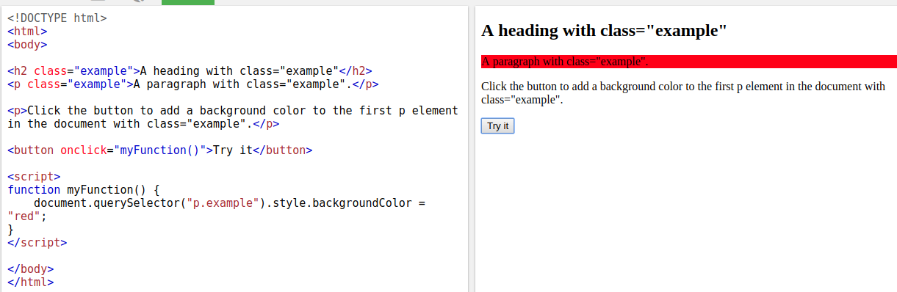

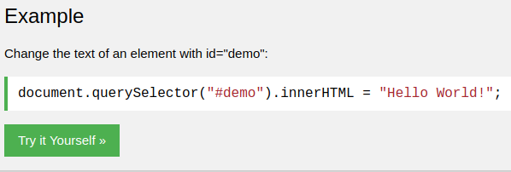

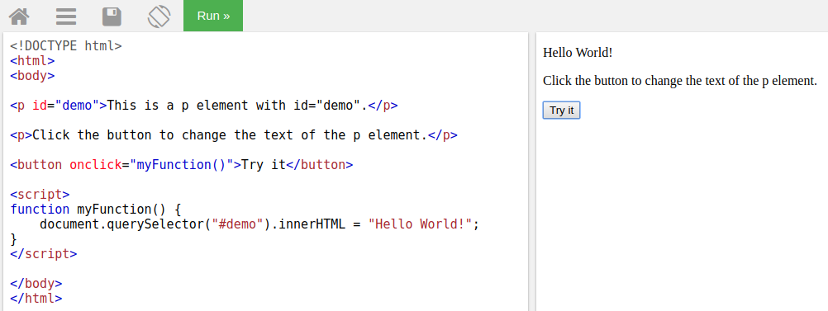

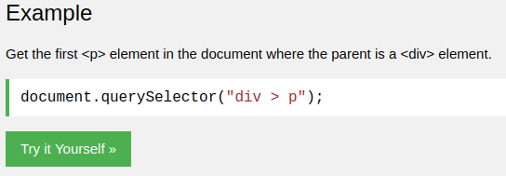

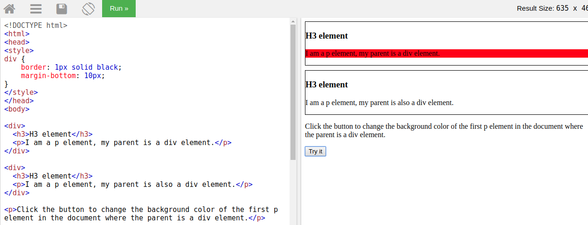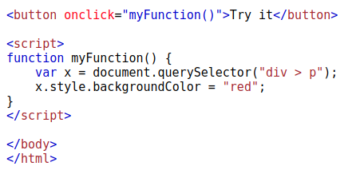

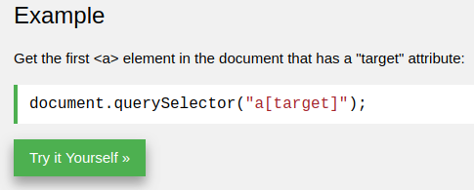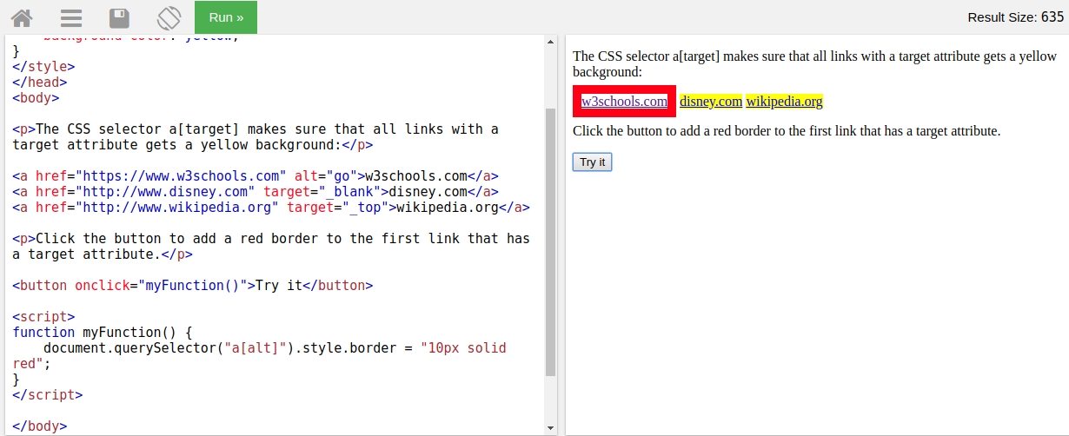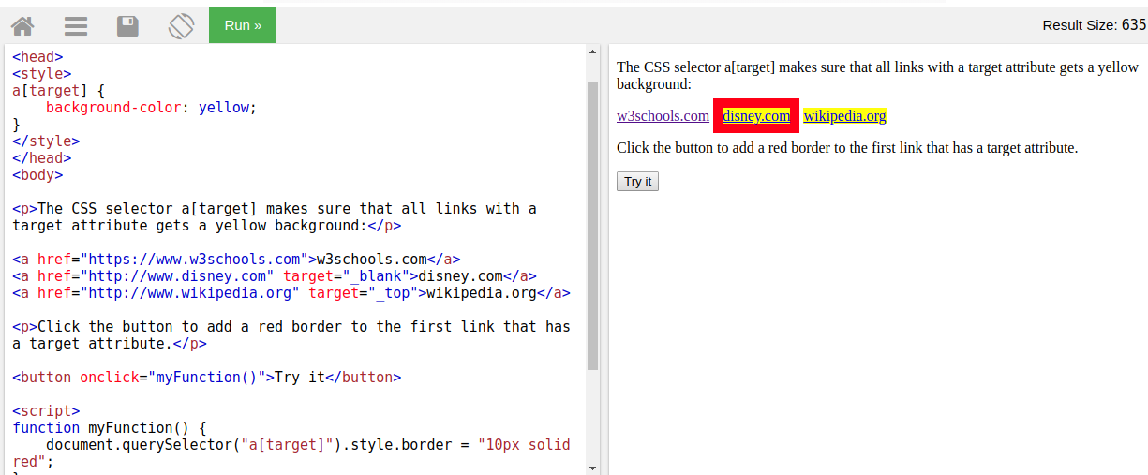

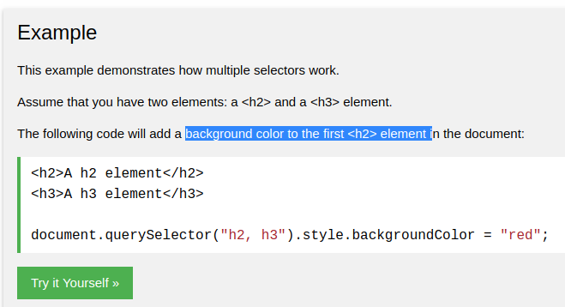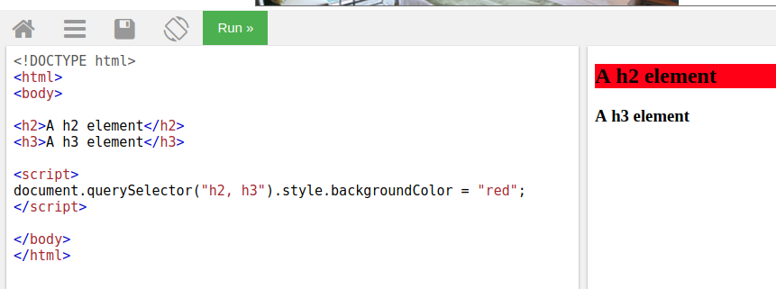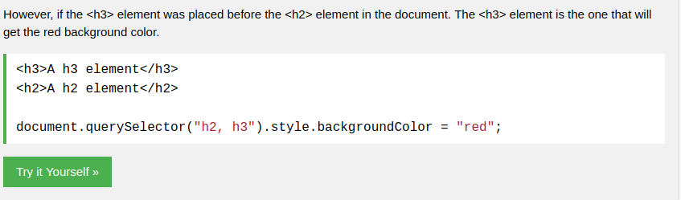

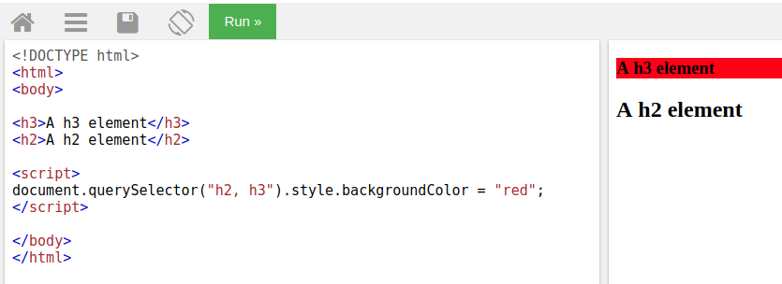

# **HTML DOM classList Property**

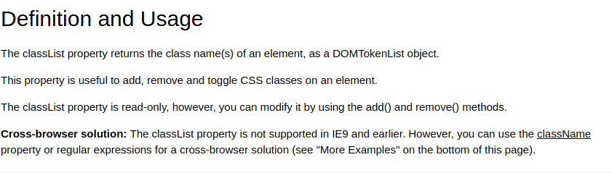

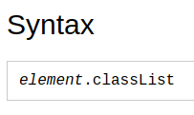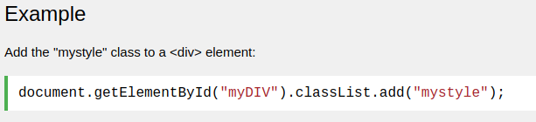

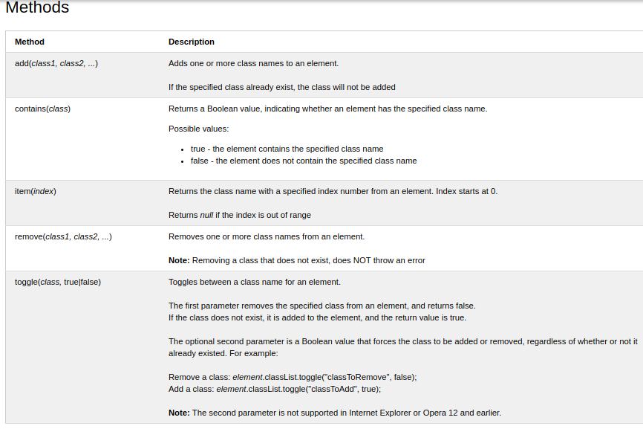

# stopPropagation()  نشر Event Method

Propagation means bubbling up to parent elements orcapturing down to child elements. **يعني الانتشار فقاعات تصل إلى العناصر الرئيسية أو الالتقاط إلى العناصر الفرعية**.

The stopPropagation() method prevents propagation of the same event from being called.

Or

the element that has stopPropagation() , it will not respond to any addEventListener() from the parent.

Ex:

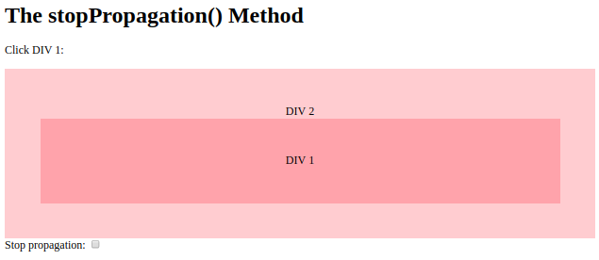

<https://www.w3schools.com/jsref/tryit.asp?filename=tryjsref_event_stoppropagation>

# HTML DOM classList Property

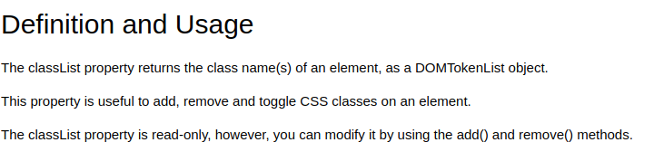

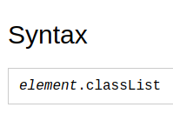

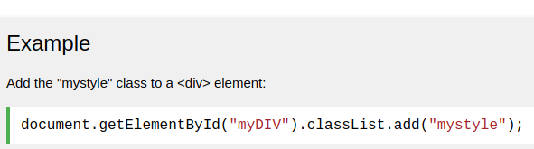

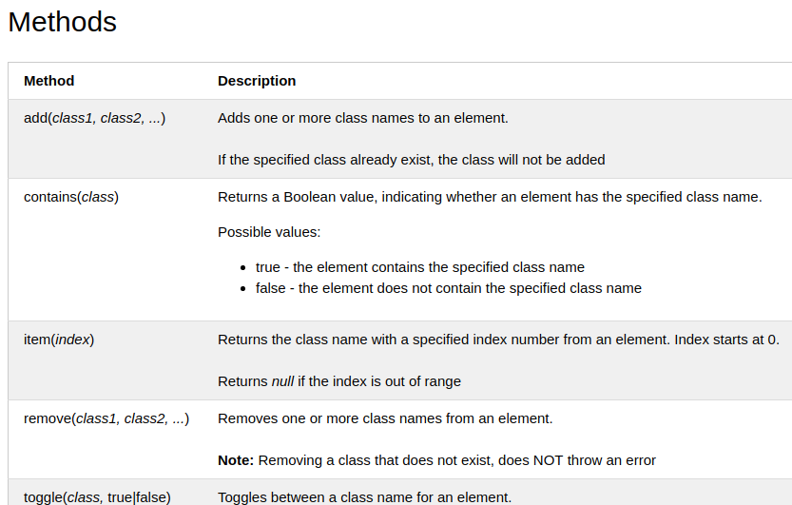

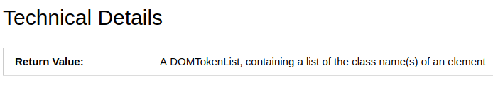

## More Examples

<https://www.w3schools.com/jsref/prop_element_classlist.asp>

# preventDefault() Event Method

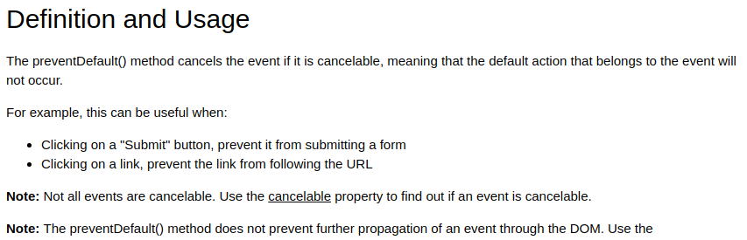

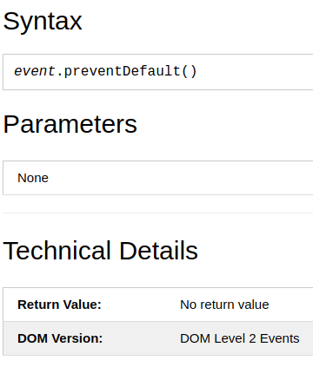

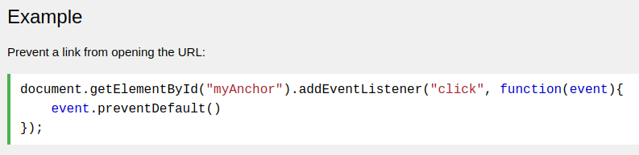

# Window scrollBy() Method

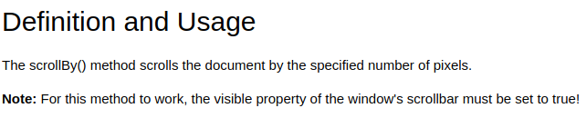

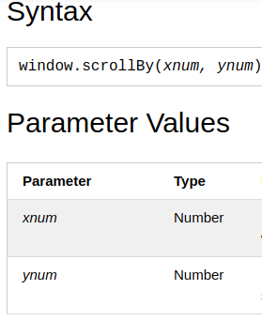

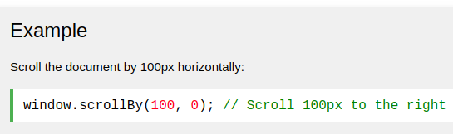

## More Examples

<https://www.w3schools.com/jsref/tryit.asp?filename=tryjsref_win_scrollby3>

# Window pageXOffset and pageYOffset Properties

Where is my scroll pixels.

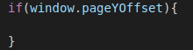



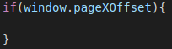

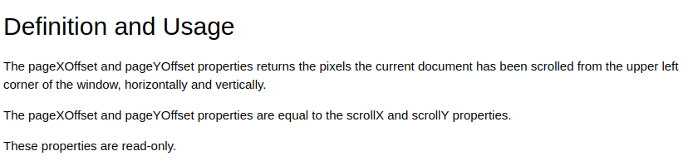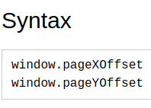

# Element offsetTop Property

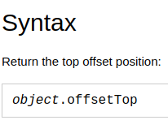

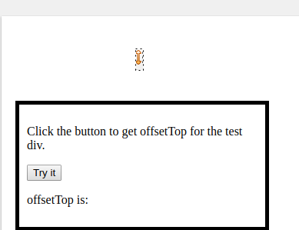

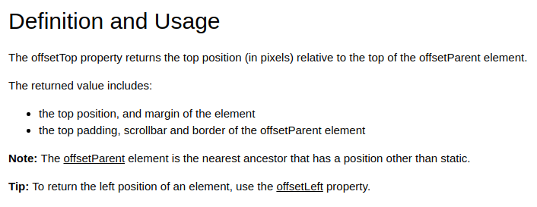

Ex 69_scrollby :

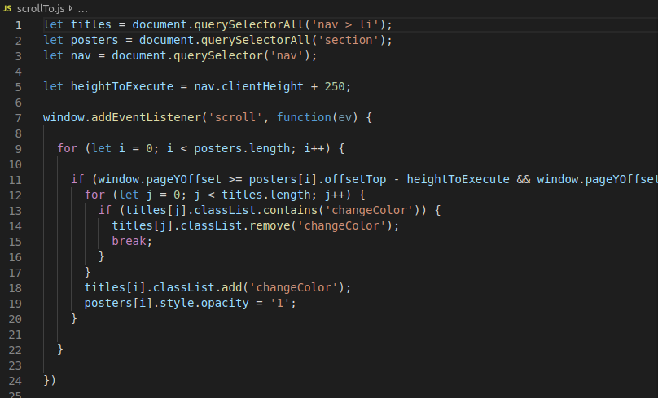

# HTML DOM clientHeight Property

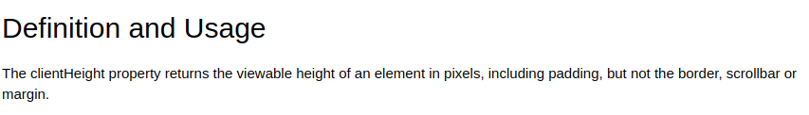

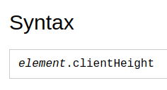

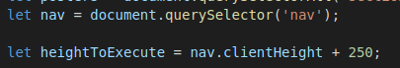

# MouseEvent clientX Property

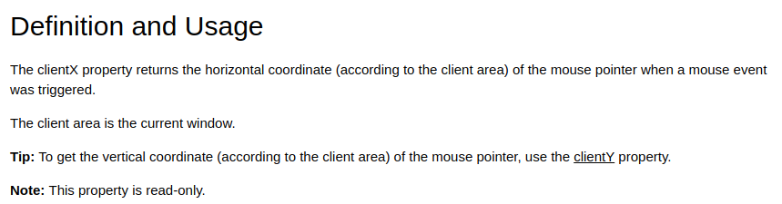

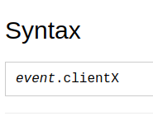

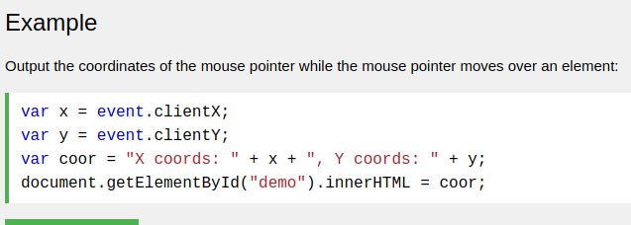

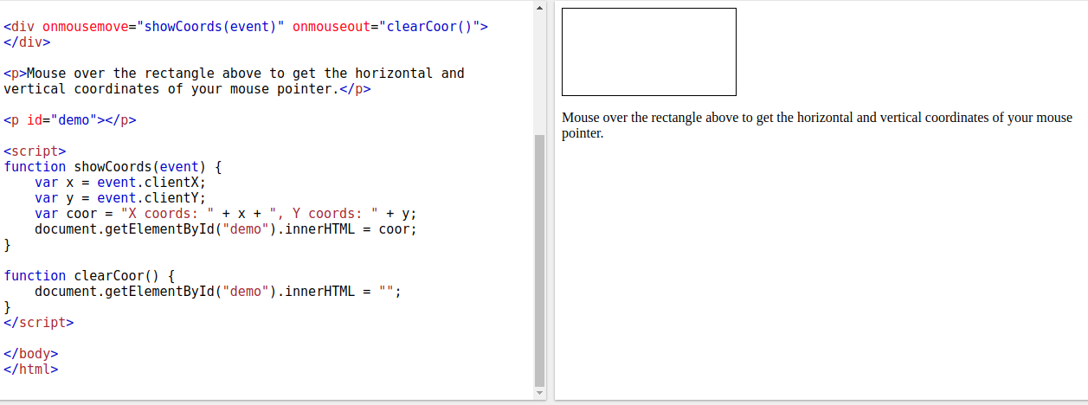

https://www.w3schools.com/jsref/tryit.asp?filename=tryjsref_event_mouse_clientxy2

# currentTarget Event Property

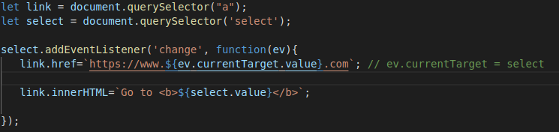

# CSS z-index Property

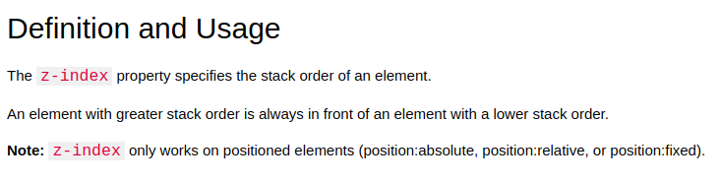





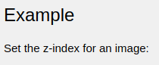

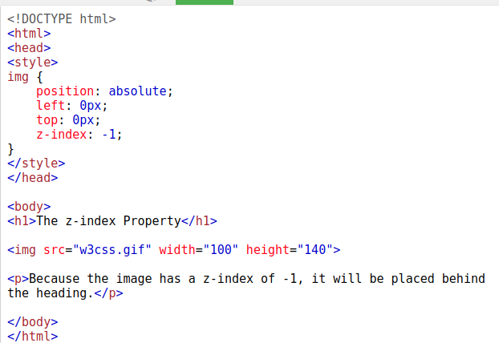

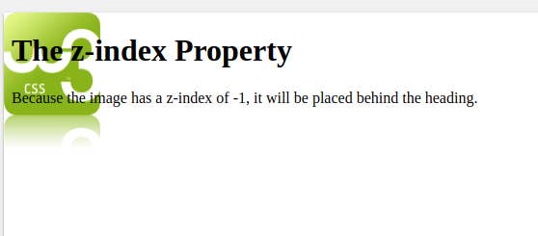

WHEN NO POSITION, **z-index** will not effect anything to image.

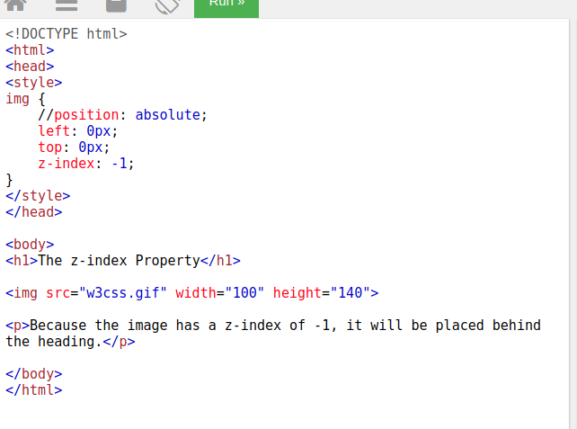

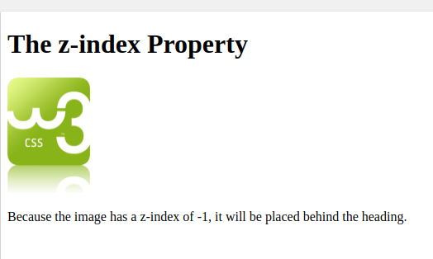

**document.addEventListener ( 'DOMContentLoaded', function (ev) {**

your js code

**})**

## -The HTML DOM (Document Object Model) = to access all Html elements after loaded.

-When a web page is loaded, the browser creates a Document Object Model of the page.

-In other words: The HTML DOM is a standard for how to get, change, add, or delete HTML elements.

**domContentLoaded** is the point when both the DOM is ready and there are no stylesheets that are blocking JavaScript execution.

- ( Scenario 1 ) ; when to add a new element on the fly by js with the document method like document.createElement('P'),

so the new element will be after JavaScript line (big problem).

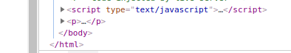

- ( Scenario 2 : to solve the problem of Scenario 1 ) ;

To move the js line to head, so the Html will start with js code , so the js code will call the html DOM eventListeners but the html DOM is not loaded yet. To solve this , it will set “document.addEventListener ( 'DOMContentLoaded', function (ev) {“ in the first line in js, so now the the js code will compile after the HTML DOM is loaded and ready.

So finally now : the element that is added on the fly by js with the document method like document.createElement('P'), will load first then js.

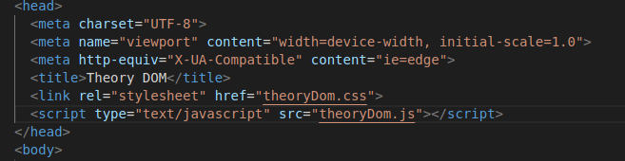

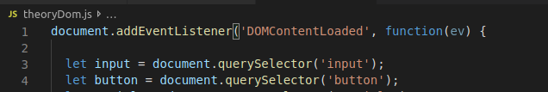

**Input text box**

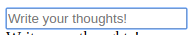



**Input password box**





**Input checkbox**

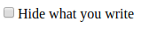



**Select bar**

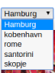

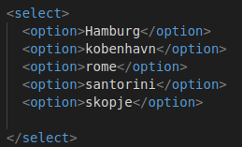

**textarea**

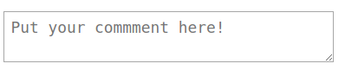



**keyup  event**

The keyup event is fired when a key is released.

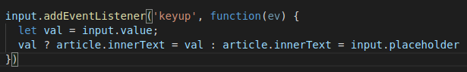

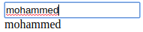

**Select to change img**



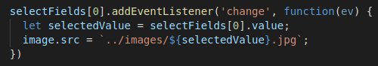

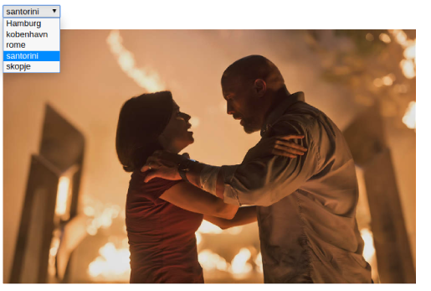

To add a new element on the fly by JavaScript

1- let var = document.createElement('P'); // musr inside ‘ ‘ a capital Letter

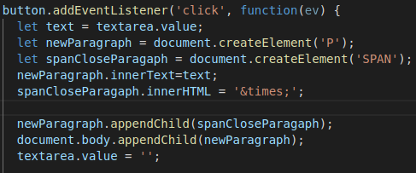2- document.body.appendChild(var); // or element.appendChild(var);

To remove a element on the fly by JavaScript

Element.removeChild(elementToRemove);

ex:

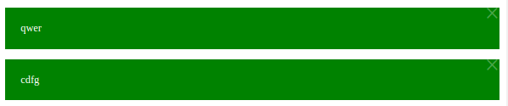

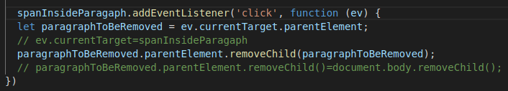

**submit event , it is only with form element**

It mean when I press enter in input box, the event will trigger.

It muss to set <button type="submit"> to button, in order to also the button triggers the submit event of form.

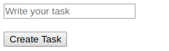

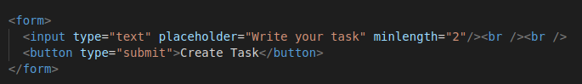

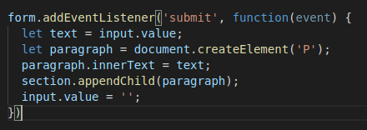

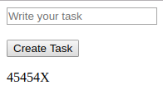

# Window localStorage Property

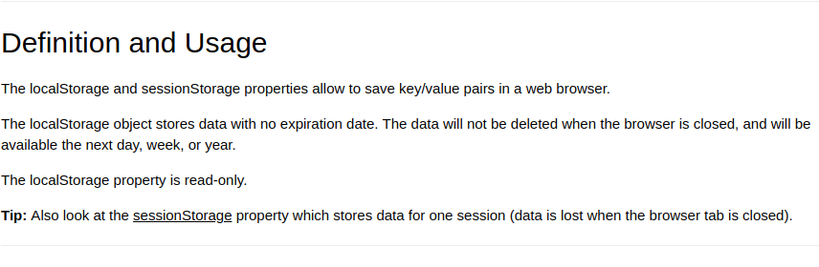

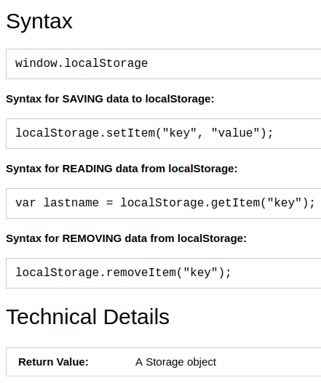

The line of example :

https://www.w3schools.com/jsref/prop_win_localstorage.asp

**how to use it :**



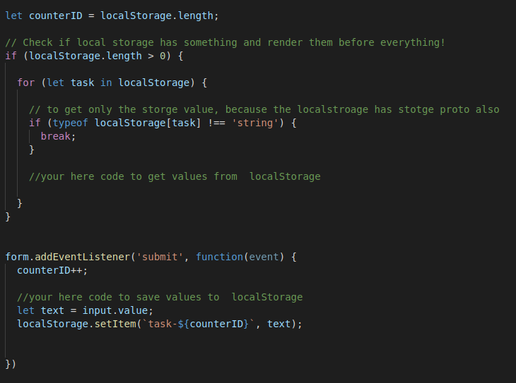

**ex:**

**73_ createElement_on_the_fly with LocalStorg**

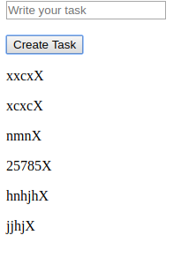

**The <fieldset> tag draws a box around the related elements.**

<fieldset>

<legend>my title</legend>

…… your code

</fieldset>

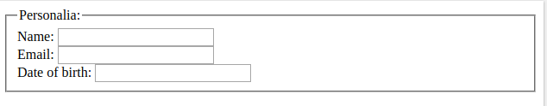

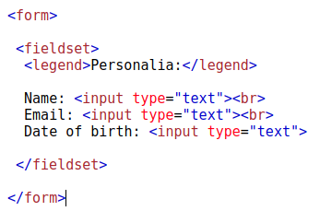

# JavaScript Regular Expressions

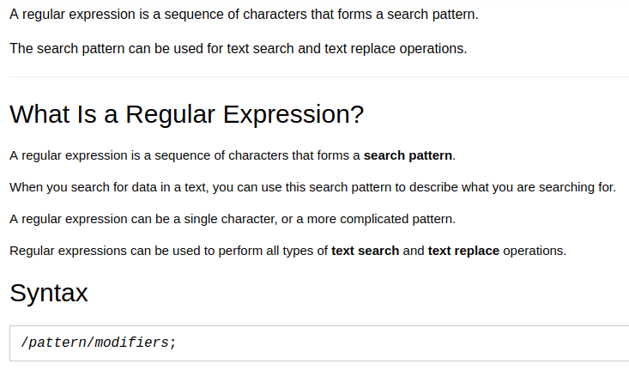**To check regex pattern: www.regex101.com**

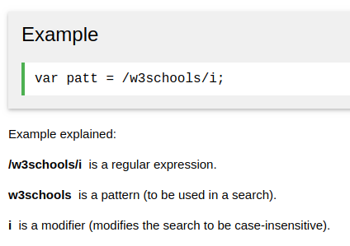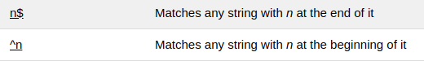

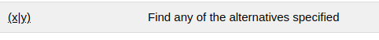

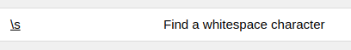



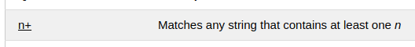

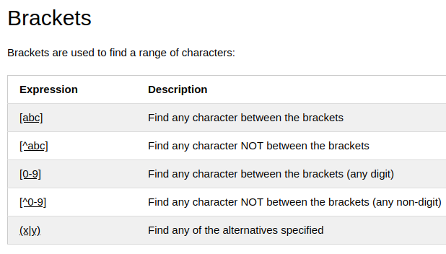

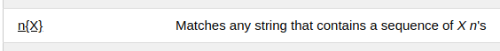

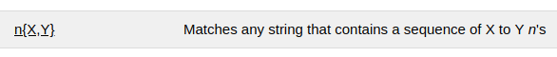

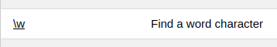

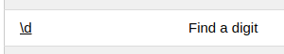

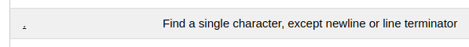

. is everything(word,numbers,sympols)

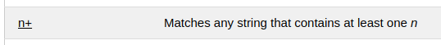

how to write / : slash + symbol = \ /



## **Self-Invoking Functions Invoking:استدعاء it used for security**

It runs only one time and not allow to call it.

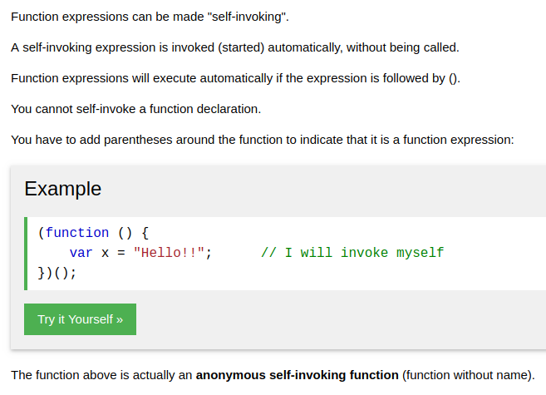

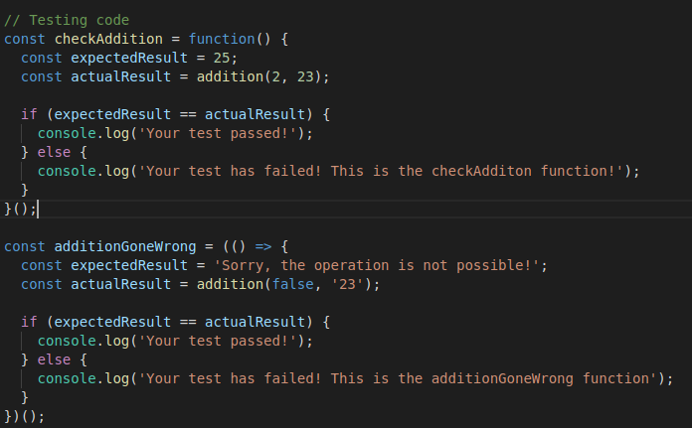

# **ECMAScript 6 - ECMAScript 2015**

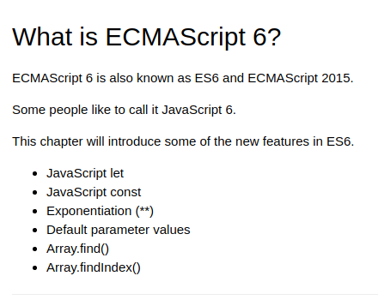

<https://www.w3schools.com/js/js_es6.asp>

Default Values in functions' parameters

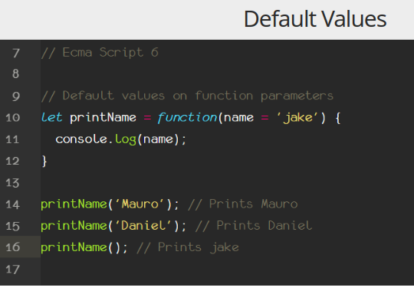

## **Arrow Functions**

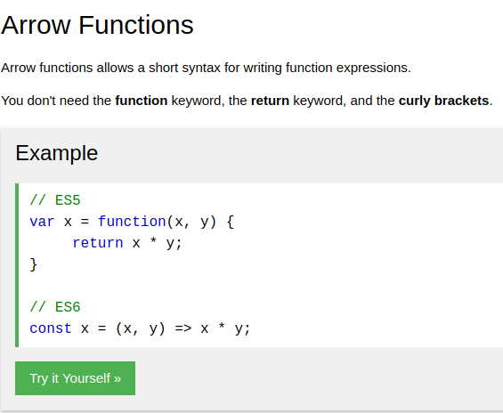

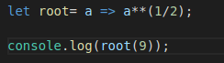

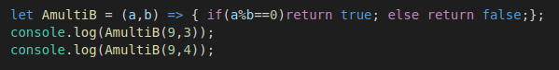

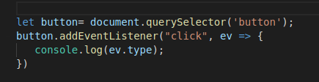

**Set.prototype Constructor (unique values of any type)**

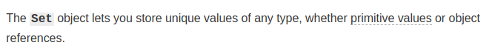

https://developer.mozilla.org/en-US/docs/Web/JavaScript/Reference/Global_Objects/Set

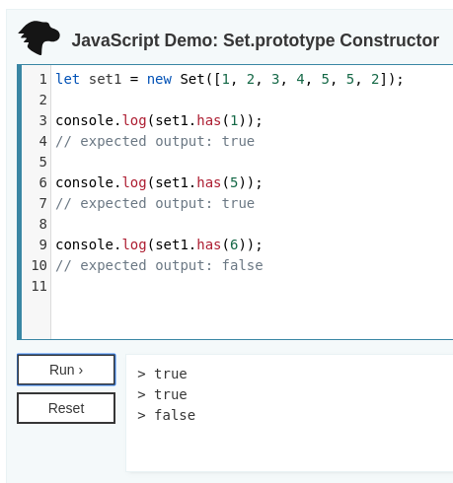

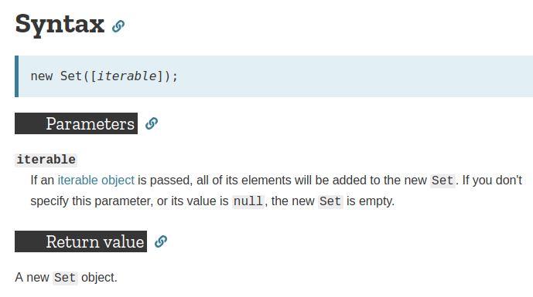

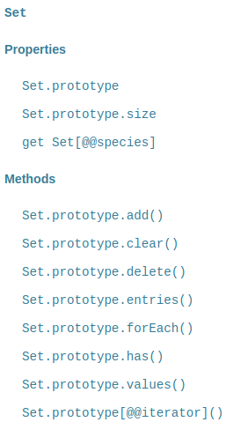

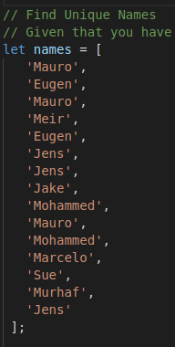

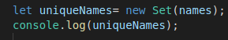

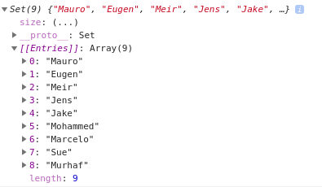

# Class based Inheritance

JavaScript classes, introduced in ECMAScript 2015, are primarily syntactical sugar over JavaScript's existing prototype-based inheritance

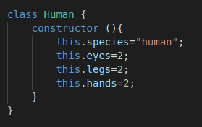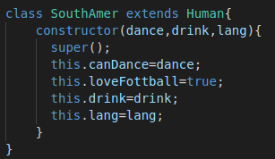

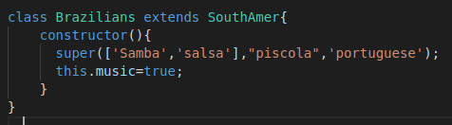

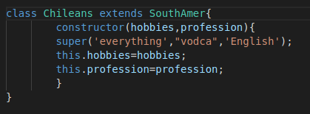

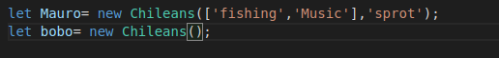

# console.table() Method

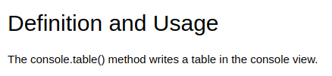

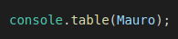

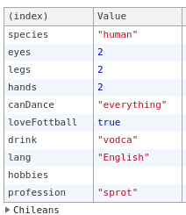

**Asynchronous Code**

it will execute alone in the end of the js file, it will not effect on the main code after it.

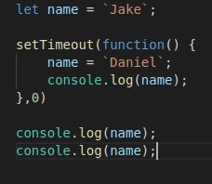

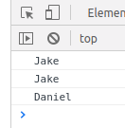

Promises , to create a Asynchronous function

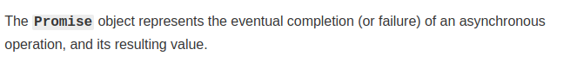



promise object means the 2 option:

completion : ==> resolve ==> .then

failur : ==> reject ==> .catch

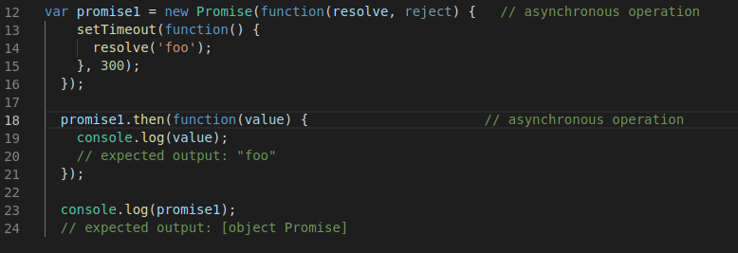

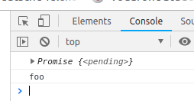

tips to create asynchronous function:

1. create a function with argument(s)

2. create a promise object inside that function

3. resolve (value), reject (message)

4. return promise object to that function

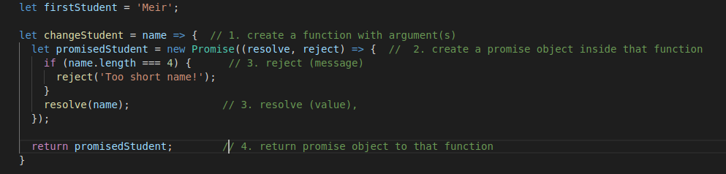

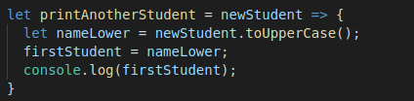

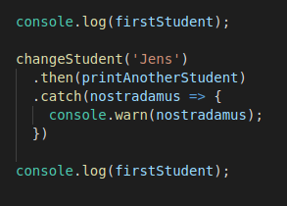

**advance of promise: .all .race**

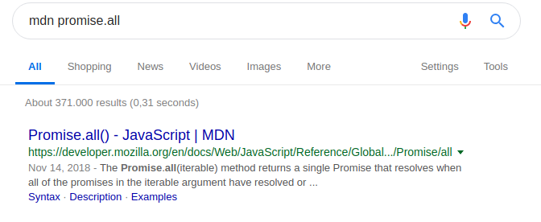

<https://developer.mozilla.org/en-US/docs/Web/JavaScript/Reference/Global_Objects/Promise/all>

f you want to work with a library that deals with promises. Bit advanced to understand though:

http://bluebirdjs.com/docs/features.html

**fetch**

it is ready function to return promise object ( .then , .catch ).

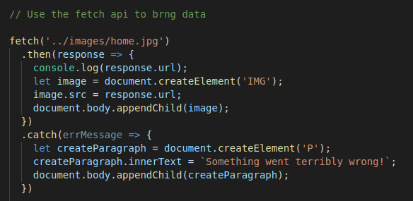

status:

200 success

401 client-error Authorization failed

404 client-error page not found

501 server down

# JSON

**It is encapsulation the data in “ “ then send , so recive the data then decapsulation**

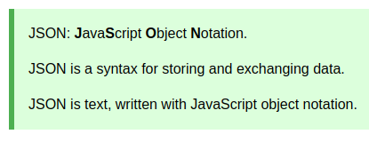

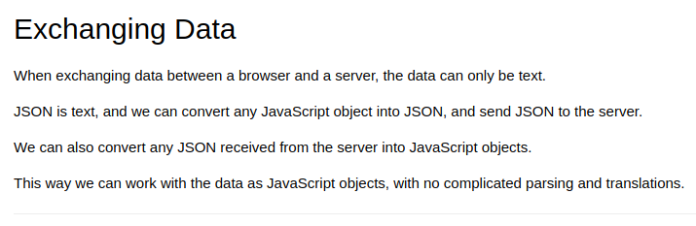

# Try to Catch

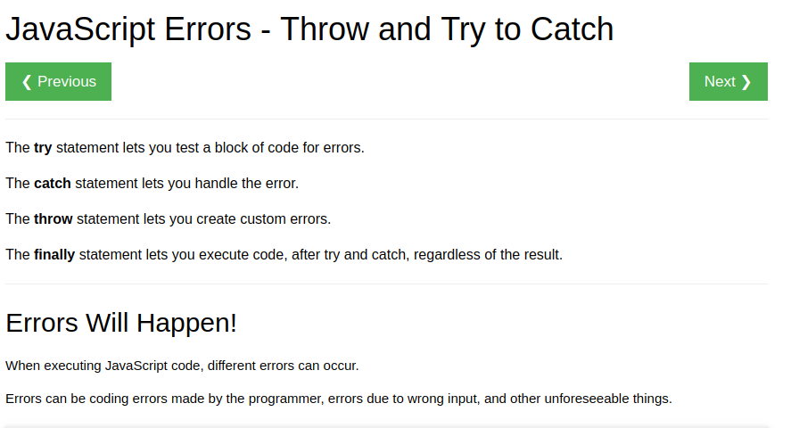

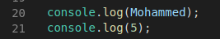

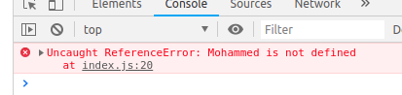

Look the error will prevent to continue the code in line 21.

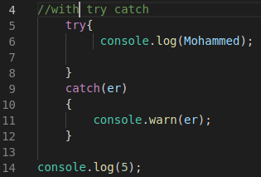

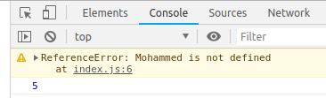

Look the error will **not** prevent to continue the code in line 14.

**callback function**

**https://codeburst.io/javascript-what-the-heck-is-a-callback-aba4da2deced**

<https://www.w3schools.com/jquery/jquery_callback.asp>

**async + await ,** to create a Asynchronous function

**it is instead of ‘**Promises function (fetch) , to create a Asynchronous function’, why ?

because the fetch.then.then.then will generate chain,

in order to cancel the chain and writr less code, so we will use (async + await).

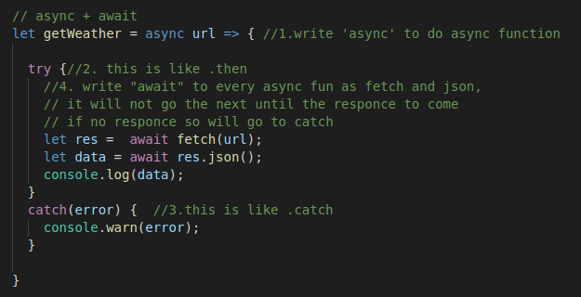

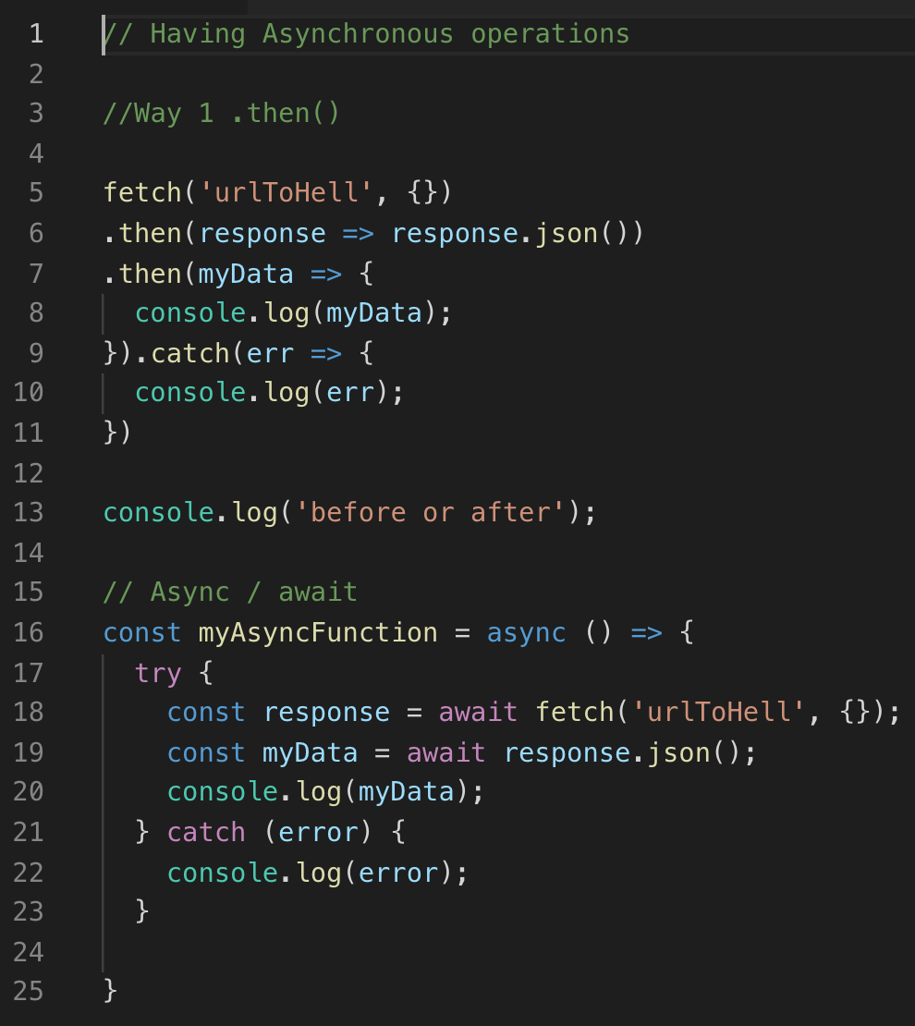

Node.js 15

Callbacks VS Promises VS Async/Await VS Rxjs

<https://www.academind.com/learn/javascript/callbacks-vs-promises-vs-rxjs-vs-async-awaits/>

-Callback asynchronous

It is oldest and simple to handle asynchronous code. It will execute after certain time as asynchronous. Its disadvantages are nested callback functions and handling the error by calling all nested callback functions.

Simple ex for callback function:

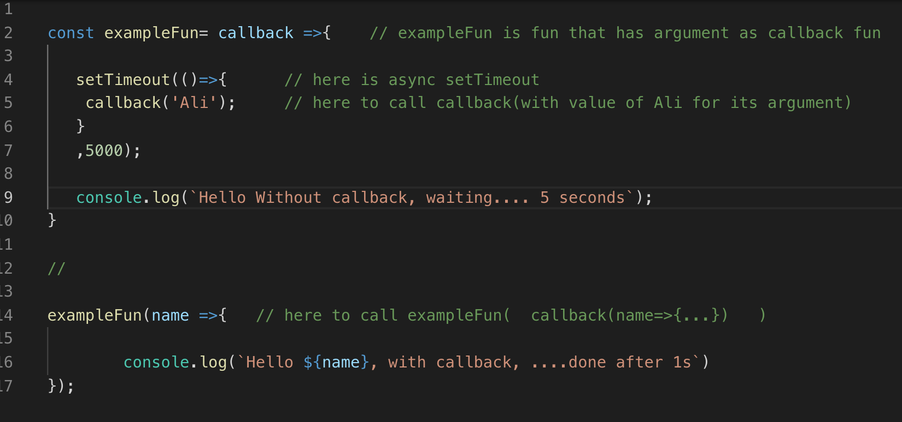

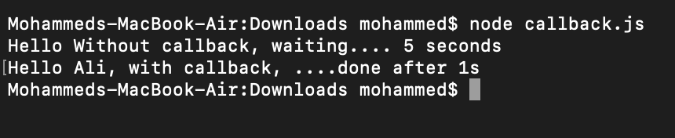

Here the mean Example

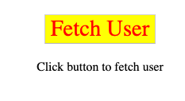

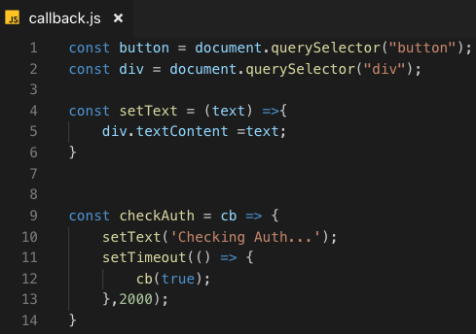

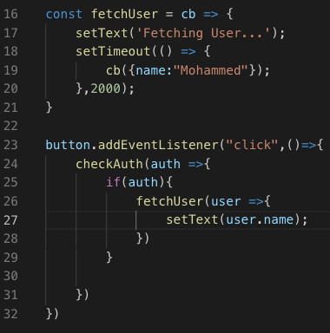

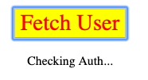

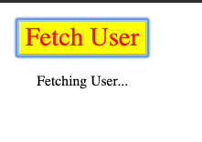

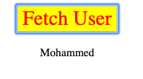

- Promises asynchronous

It came with ES6, ECMAScript 2015.

https://medium.com/@ThatGuyTinus/callbacks-vs-promises-vs-async-await-f65ed7c2b9b4

https://www.codecademy.com/learn/asynchronous-javascript

## API

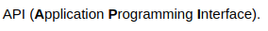

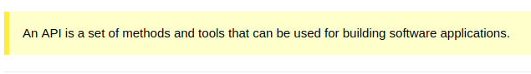

# focus() Method

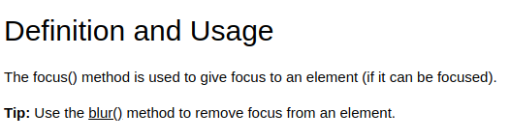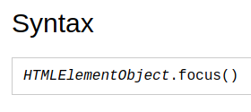

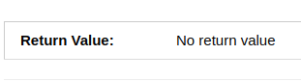



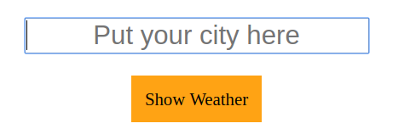

**to use asynchronous function with delay timeout ,** Promise.all

folder: 86_to use asynchronous function with delay timeout

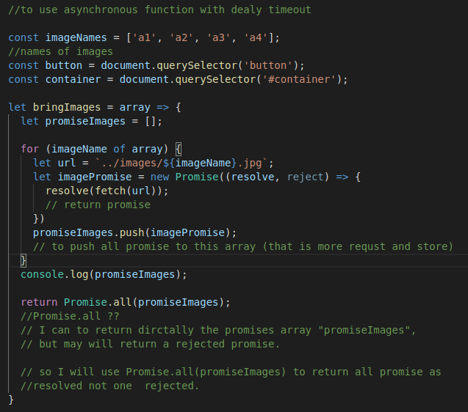

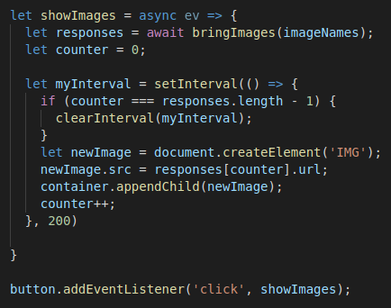

# jQuery

**$(this).**

In JQ ; $(this) = .currentTarget

-not who is called the function in JS

-not working with arrow function =>

**append(), prepend()**

to add children.

**.after , .before()**

To add siblings.

**.remove()**

remove the element itself

**vanilla js vs jQuery**

innerText ==> text()

innerHtml ==> html()

Value ==> val()

**$.ajax(in jQuery) vs Fetch (in vanilla js)**

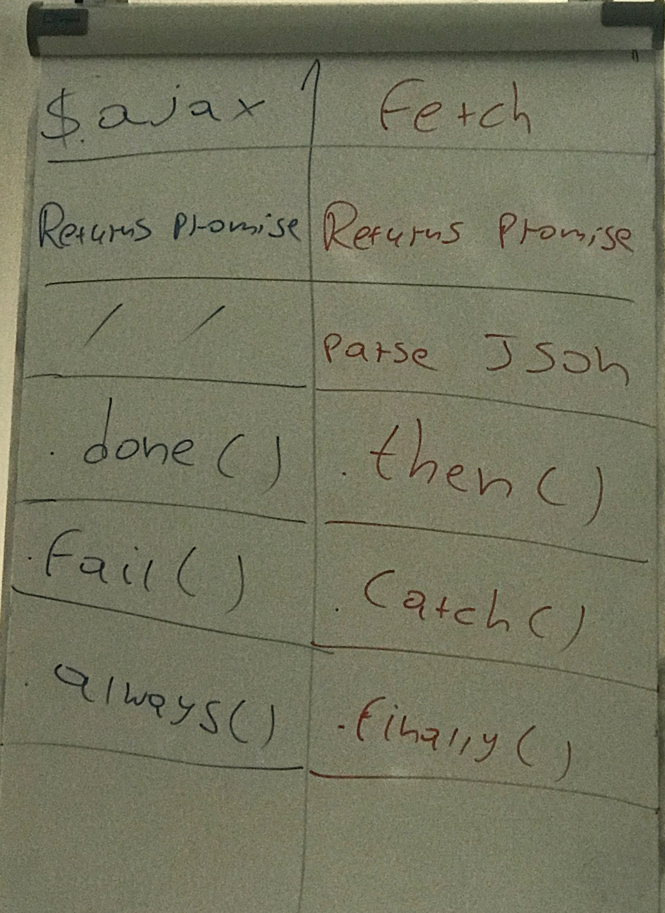

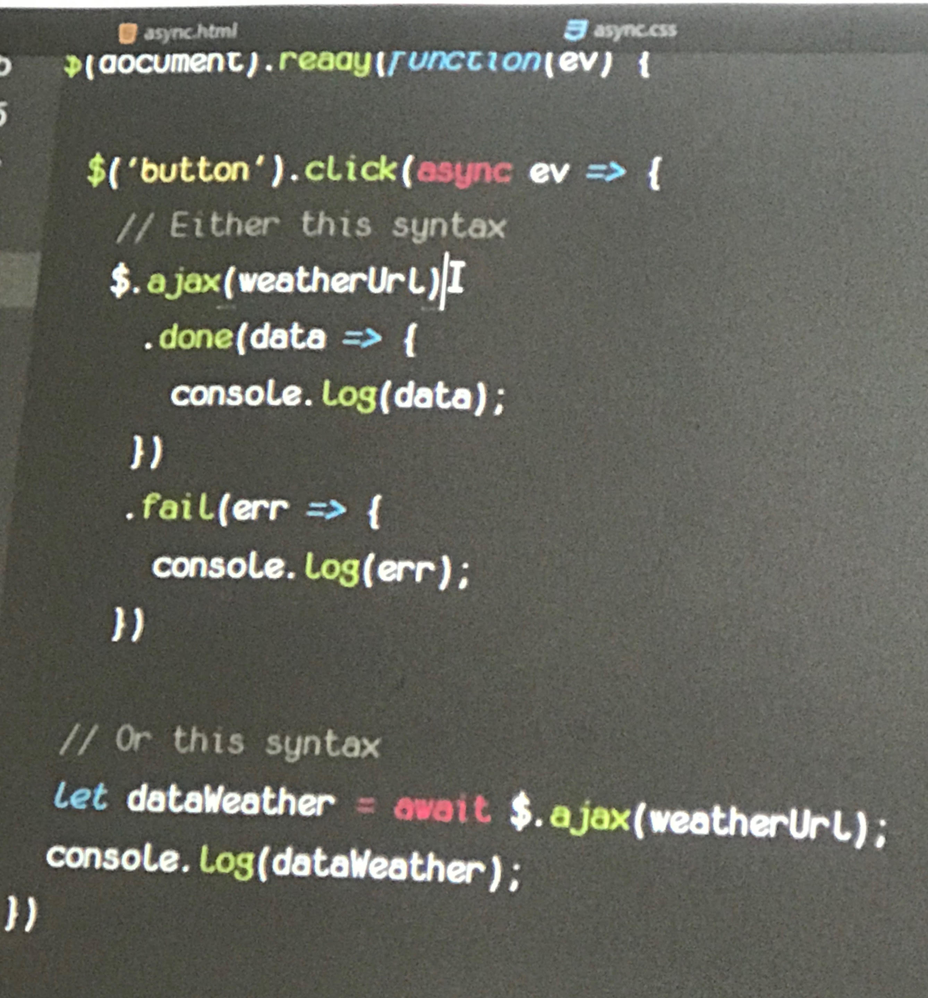

**https://jqueryui.com/**



# Media Queries

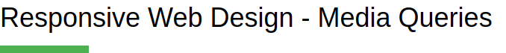

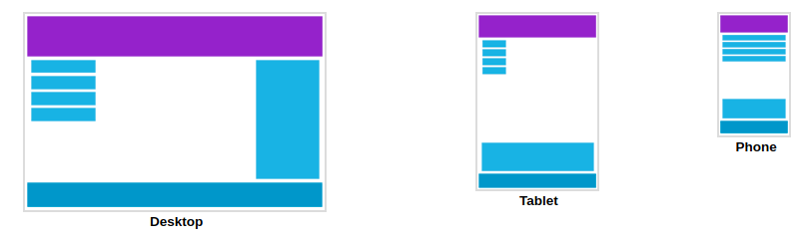

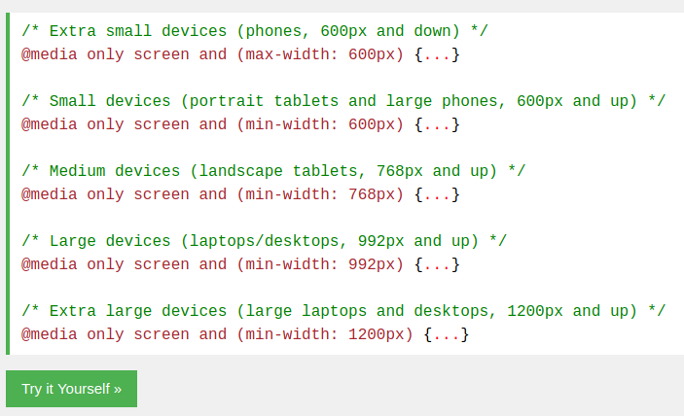

[**https://www.w3schools.com/css/css_rwd_mediaqueries.asp**](https://www.w3schools.com/css/css_rwd_mediaqueries.asp)

**export import js**

1. do this for source and destination

delete this



add this



2.

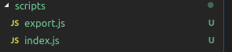

3.

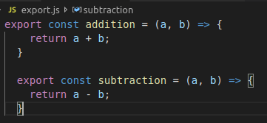

4.

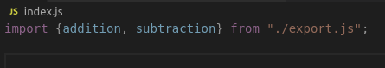

**mocha test with node.js**

1- the video : 2019-01-09 Test_Setup_mohammed_whflv

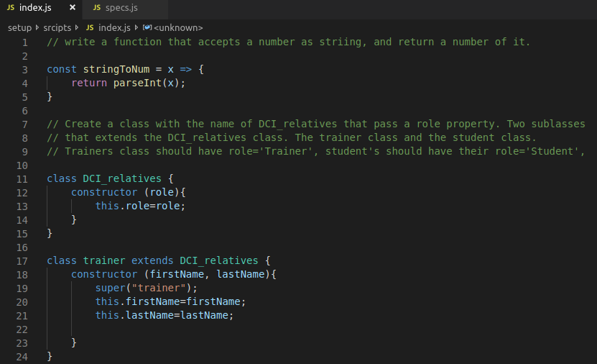

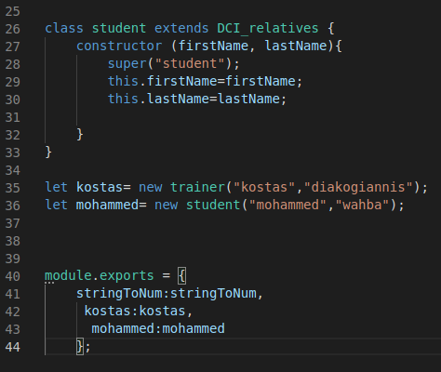

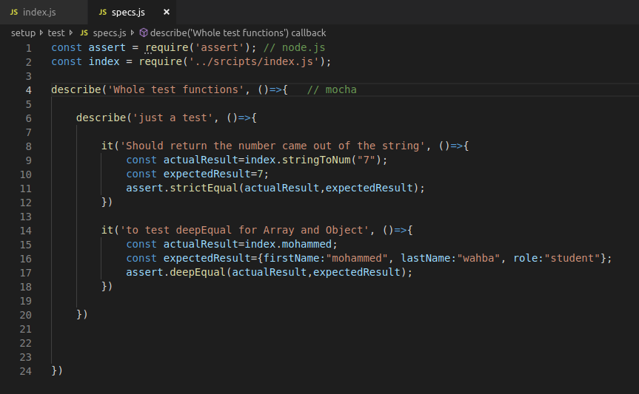

**react**

commands in terminal :

npm install --save react

npm install --save react-dom

npm install --save-dev @babel/preset-react

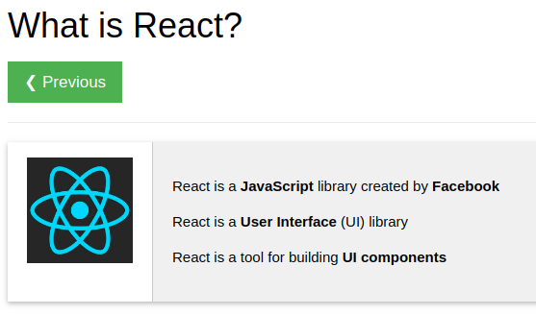

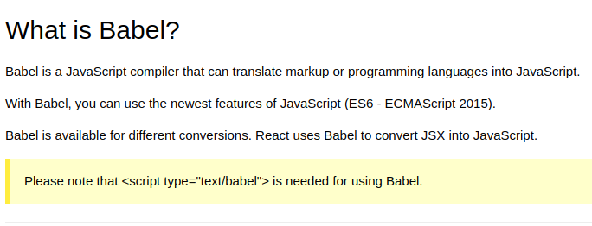

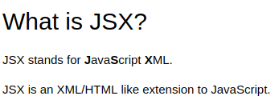

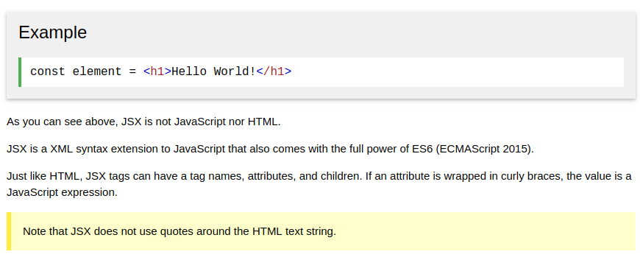

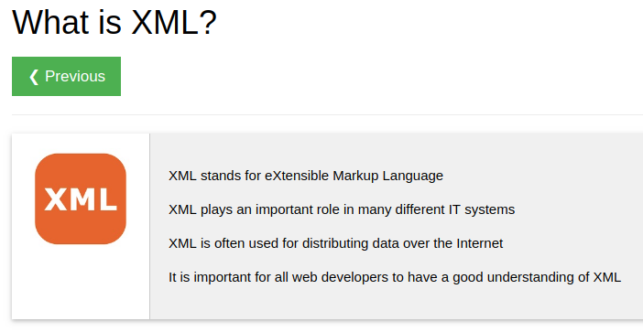XML is before  JSON

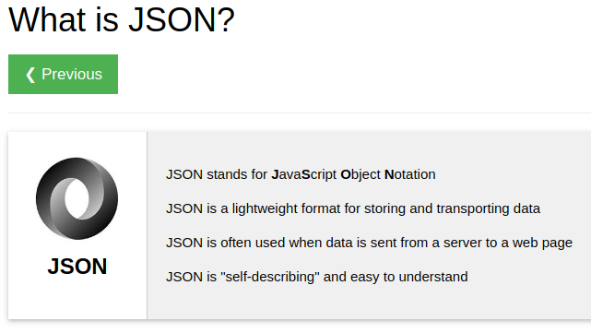

let come back to react:

**Routing**

**https://itnext.io/the-easiest-tutorial-on-react-router-v4-youll-ever-find-build-a-single-page-application-in-44c453f4123b**

SPA : Single page Application

MPA ; Multi Page Application

**----------------------------------------------------------------------------------------------------------------**

**JavaScript Array**find()**Method**



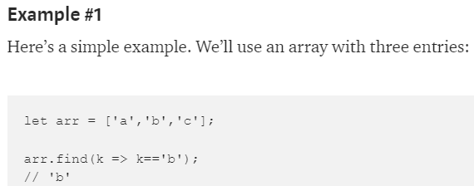

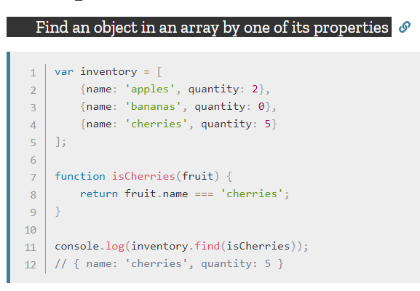

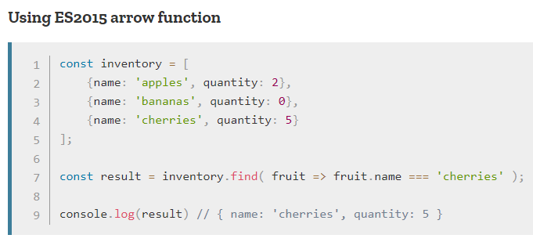

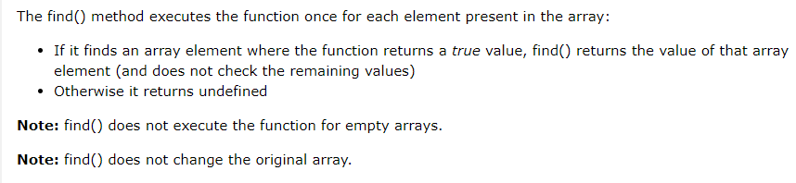

# -------------------------------------------------------------------------------------------------------

# JavaScript Array findIndex()

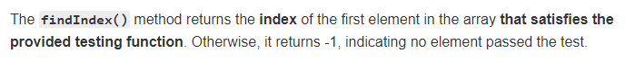

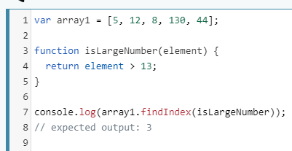

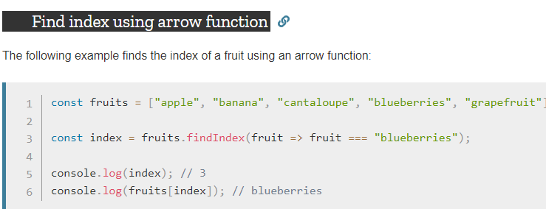

# JavaScript Array map() Method

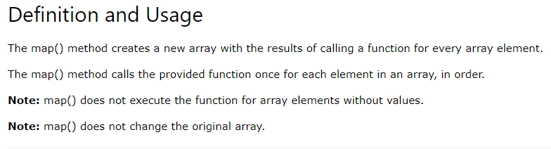

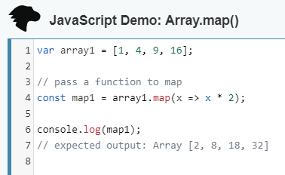

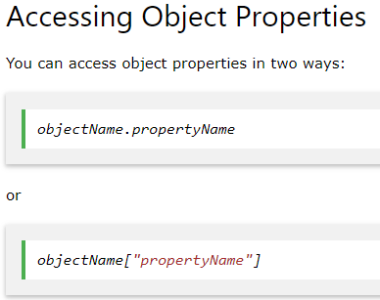

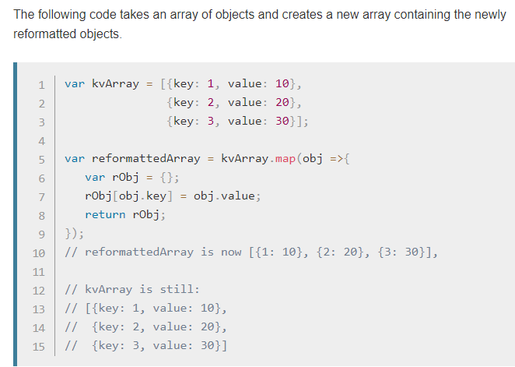

# JavaScript Array forEach()

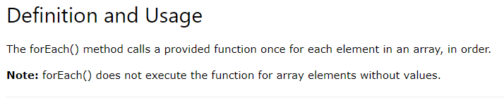

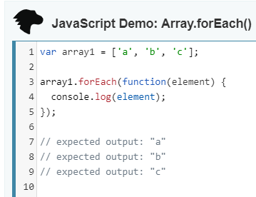

* forEach() doesn't change the original array.

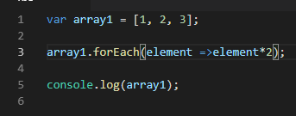

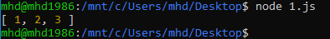

**JavaScript Array**reduce()

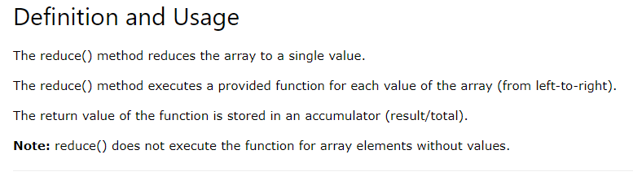

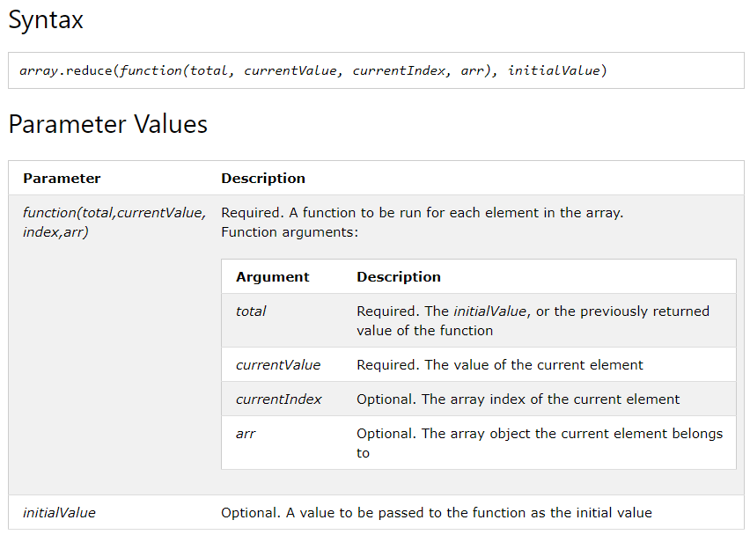

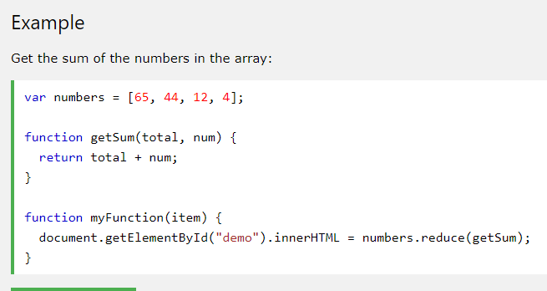

ƒ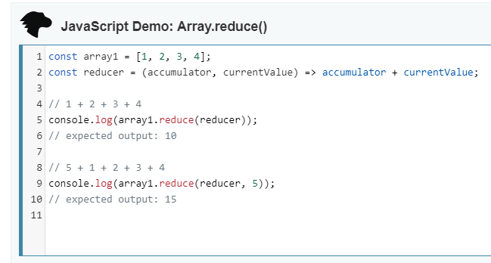

Understanding ‘this’ keyword in arrow function

# The JavaScript this Keyword

<https://www.youtube.com/watch?v=Pv9flm-80vM&feature=youtu.be>

Temp

css Example

Css Example

css Example

Css Example



https://www.w3schools.com/js/js_arithmetic.asp